Impact of Operations Changes on Sustainability of a Small-Scale Biogas System
Matt Steiman, Summer 2020

Abstract: Biogas systems process farm residues into burnable gas and crop fertilizer. While biogas projects may have many sustainability attributes, a full picture of system sustainability requires thorough life cycle analysis. This study uses life cycle cost analysis and emergy analysis to assess financial and environmental sustainability of the 7.5m³ biogas system at the Dickinson College Farm (Pennsylvania, USA). Operational parameters (loading rate and method of digestate distribution) were varied to study sensitivity across both LCC and emergy analyses. Sustainability increases when the biogas system is loaded to full capacity, so long as all biogas produced is used and none is released as free methane. Eliminating redundant use of fossil fuel powered machines for digestate transfer also increases sustainability. LCC and emergy analyses are useful tools for holistic assessment of biogas projects.

Introduction:
Biogas systems provide renewable energy and fertilizer from agricultural and food processing residues (Li et al. 2012, Alburquerque et al. 2012). Through microbial processes collectively known as anaerobic digestion, feedstocks such as livestock manure and food waste are diluted with water and placed in a warm, oxygen-free environment. The end products are a nutrient rich liquid fraction known as digestate or effluent, and biogas (primarily CH₄ and CO₂ with other trace gases) (House 2010). Analogous to natural gas, biogas is combusted for cooking and heating (Lansing et al. 2010; Vu et al. 2015) and can fuel generators for electricity production (Ciotola et al. 2011, Lansing et al. 2008). Biogas systems can function beneficially at a range of digester sizes – from 6m³ household-scale systems common on Vietnamese farms (Roubik et al. 2016) to projects capable of digesting the daily waste of 3000 cows in the US (Lauer et al. 2018).
At first glance, biogas systems meet many sustainable engineering criteria within the three primary categories (ecological, social and economic sustainability) as described by Abraham (2006). Processing manure into gas and fertilizer can reduce water and soil pollution (Chara et al. 1999; Vu et al. 2015), while also decreasing emissions of methane – a potent greenhouse gas – from open manure storage lagoons (Ciotola et al. 2011, Wang et al 2014). Providing a source of renewable energy can reduce consumption of fossil fuels (Vu et al. 2015), lessen demand for firewood in overharvested areas (Mwirigi et al. 2014), and improve indoor air quality if replacing low grade combustion fuels (Singh and Sooch 2004). Diverting food residues from municipal waste decreases landfill loading and reduces costs for waste generating businesses (Brandt and Martin 2001). Biogas systems can improve farmer quality of life by reducing neighbor complaints about odors (Anaerobic…2012) and can alleviate rural poverty in developing countries by providing easy to use cooking fuel to households (Singh and Sooch 2004) without the burden of collecting fuel remotely. Energy outputs, liquid fertilizer and solids separated from digestate for use as livestock bedding all have economic value. Financial sustainability is achievable as some biogas systems have a short payback period (months or years)(An et al. 1997). For these reasons and more, biogas systems are actively promoted by governments around the world (Holm-Nielsen et al. 2009, Feng et al. 2012), with millions of installations in China, India, and nearby developing countries (Bruun et al. 2014).
However, the circumstances of each individual biogas installation are different, and closer inspection of any project may reveal a more murky sustainability picture. System profitability depends on high output to total cost ratio - life cycle cost (LCC) analysis can identify economic shortcomings. If biogas systems leak methane to the atmosphere, the resulting net greenhouse gas emissions may be on par with conventional fuel sources (Bruun et al 2014; Paolini et al. 2018). “Emergy” analysis – a life cycle accounting of the solar energy equivalent invested in materials, labor, and natural resources to construct and operate a biogas project – can depict shortcomings in net ecological value of some system designs (Ciotola et al 2011, Wang et al. 2014). Some project owners become dissatisfied and may reject biogas technology if plagued by low productivity, equipment problems or if they lack a thorough understanding of system operations – thus education of biogas system users is also an important factor in project success (Roubik et al. 2015, An et al. 1997, Zhou et al 2011).
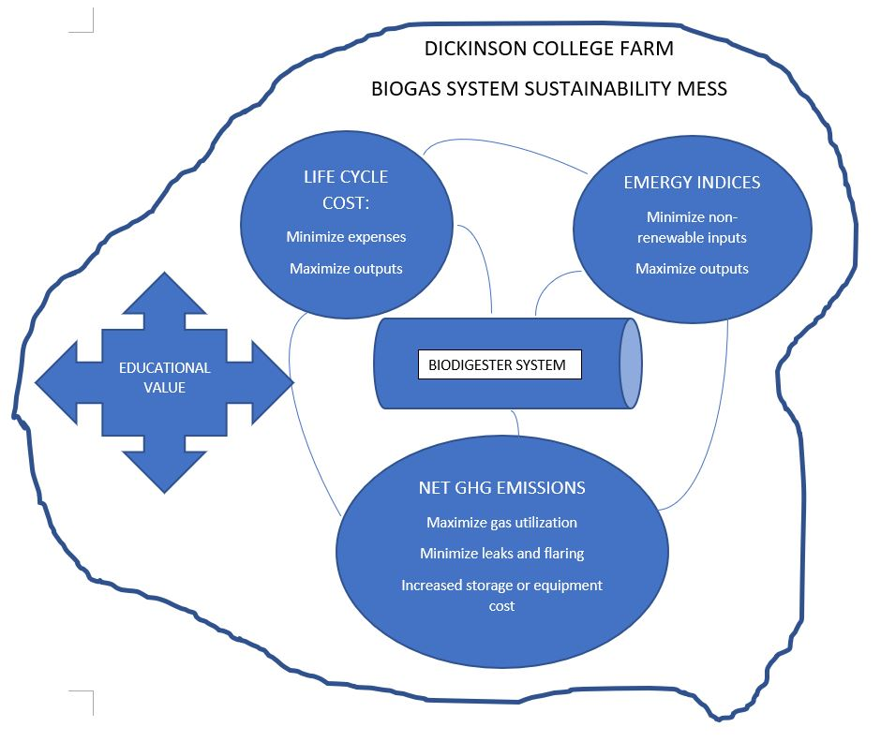
This study will examine the 7.5m³ biogas plant in operation at the Dickinson College Farm since 2015. Life cycle cost analysis, a simplified emergy analysis, net greenhouse gas emissions, and educational value will be considered for a holistic picture of overall project sustainability. Spreadsheet calculations will be used to assess the impact of changing operational parameters on sustainability indices, with the ultimate goal of improving operations to maximize the net environmental benefit of the project. The interplay of sustainability goals for the biogas project is depicted in figure 1, Mess Analysis.

Fig 1: Mess Analysis

Methods:
Study site: The biogas system studied consists of two 3750L plug flow type digesters placed in insulated trenches within a small greenhouse (fig 2). The digesters are made from EPDM roofing membrane glued into a 1m diameter tube shape, sealed at each end with custom-made plastic end caps that feature valves for fluid and gas entry and exit. Loading occurs by mixing cattle manure and ground cafeteria scraps (hereafter food residue or FR) with water to a dilution of 10% solids in an elevated tank. Under normal operations the digesters are fed only food residue after seeding with cattle manure for microbial culture. Feedstock slurry enters the digester by gravity flow and forces an equivalent volume of finished digestate liquid into an effluent pit below the opposite end. An electric pump then transfers digestate to a trailer mounted field distribution tank equipped with a gasoline powered sprayer pump and hauled with a diesel tractor to crop fields for application. Biogas is collected in EPDM bags, which are moved to the point of use on manually operated push carts. Gas is pumped from storage bags to biogas stoves for household and commercial cooking. The digesters are operated at mesophilic temperatures (~35C) which limits biogas production in the unheated greenhouse to May through September (154 days or 22 weeks). Fig 2: Dickinson digester (one unit shown).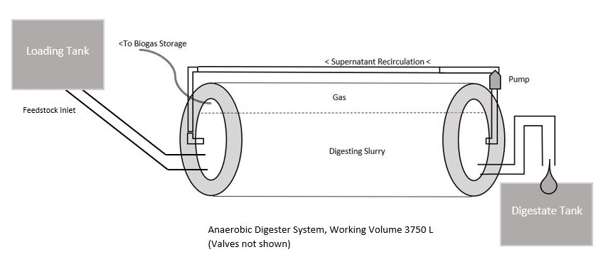
Previous work and current status: In an unpublished 2016 study, Bucknell University engineers DiStefano and Shust examined steady-state production parameters of the Dickinson biogas system over several months, documenting yields of 0.146m³ biogas/kg FR and 0.096m³ CH₄/kg FR, and a proven sustainable loading rate of 21.4 kg FR per day at 30 days hydraulic retention time. In practice however, loading rates below the proven maximum are common due to competing farm priorities for labor and inconsistent demand for biogas as cooking fuel. For three of the past four years, one of the two digester units has been inactive, and the primary digester often operates below maximum capacity. Gas storage logistics result in occasional accidental release of biogas to the atmosphere. Innovative attempts at creative utilization of biogas notwithstanding (powering a soil sterilization steamer and engine driven log splitter), sometimes it is necessary to flare biogas (rather than release it) when cooking demand does not keep up with production.
Operational changes considered: This study examines the impact on life cycle cost accounting and emergy sustainability indices of the following changes to normal operations:
- Varying loading rate, treatments as follows, 22 weeks per year:
  - “1/2 capacity”: one digester running at half capacity, equivalent to 10.7kg FR/d
  - “1 full”: one digester running at full capacity, equivalent to 21.4kg FR/d
  - “2 full”: both digesters fed 21.4 kg FR/d each
- Eliminating gasoline and diesel fuel from digestate distribution system.
  - This can be achieved by pumping digestate to commercial compost piles adjacent to the digester site via the electric pump already in use for digestate transfer to the trailer tank. Compost is applied mechanically to the same crop fields as current digestate distribution, so this step would eliminate redundant equipment, labor and fuel expenditures.
Results:
Life Cycle Cost accounting: Detailed background LCC calculations for the biogas system are included in the supplemental material attachment. Summary data depicting the results of different treatments over a 7 year expected lifespan are shown in table 1.
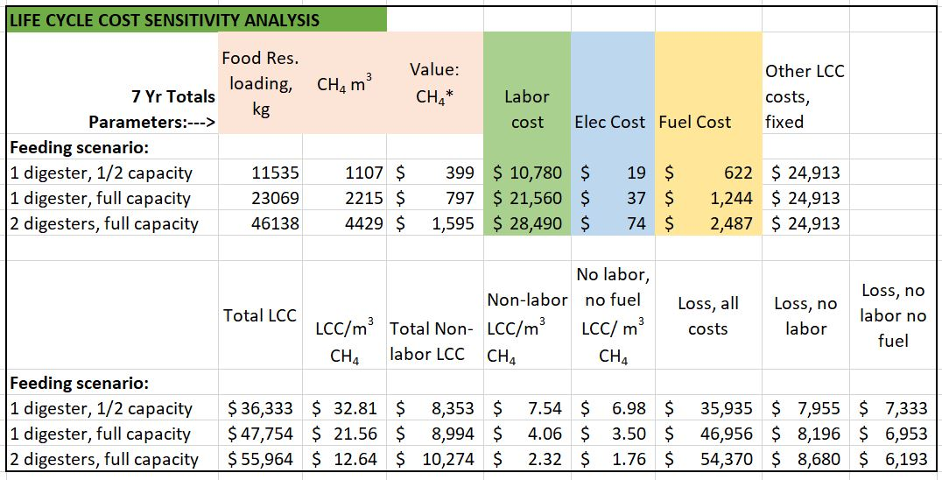
Table 1- LCC Accounting: This table depicts the results of consistent operation of the biogas system at various food residue loading rates over 7 years (22 weeks/yr). Note that as FR loading rate increases, methane production and value increase, but so do labor, fuel and electricity costs. However, the other costs (construction, maintenance, and end of life disposition) remain fixed for all treatments, resulting in a lower cost per m³ of methane produced at higher loading rates. The impact of removing fuel cost through operational change and removing labor cost (characteristic of a subsistence or homesteader system) are also depicted.
Emergy Analysis: Developed by ecologist Howard Odum in the 1980s, emergy analysis provides a means of comparing the sustainability of enterprises by converting all energy and material inputs into solar energy units (Solar Equivalent Joules – sej) using transformity values derived through published research. Ratios of inputs and outputs are calculated to evaluate how well a system utilizes non-renewable resources to leverage production of beneficial outputs. The emergy accounting for the Dickinson biogas system and calculated indices are depicted in table 2 and 3 below:
Table 2: Emergy analysis of Dickinson College Farm biogas system. Transformity references provided in attached supplemental materials.
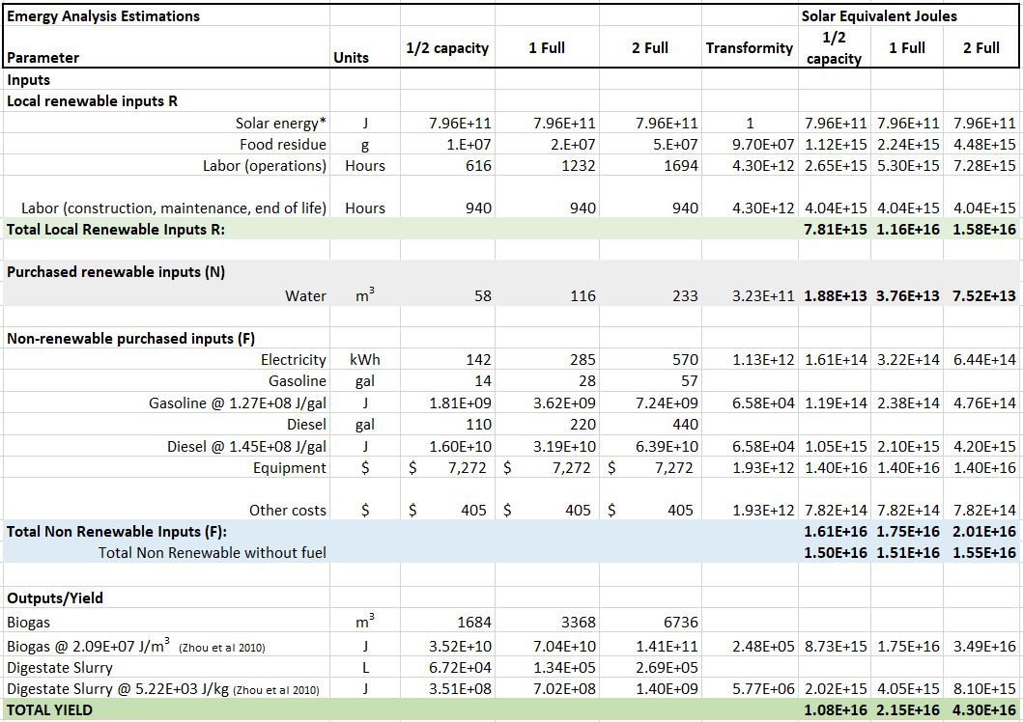
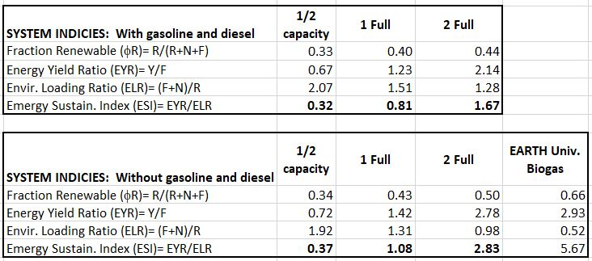
.
Table 3 (right): Emergy sustainability indices including calculations with motor fuels removed. Data from Ciotola et al. 2011 study of EARTH university biogas included for comparison

As described in Ciotola et al. (2011) and Ulgiati and Brown (1998):
- The fraction renewable (φR) index depicts the portion of system emergy inputs derived from local renewable resources.
- Energy yield ratio (EYR) is the yield of beneficial outputs relative to non-renewable inputs.
- Environmental loading ratio (ELR) depicts non-renewable and purchased renewable relative to local renewable inputs
- Emergy Sustainability Index (ESI) is the ratio of EYR to ELR.
Discussion:
LCC: Given the low cost of natural gas in the US ($0.36 per m3 in 2019 (EIA.gov…2020)), the Dickinson biogas system is not a sustainable project on purely economic terms. Increasing production to full capacity does reduce the life cycle cost per functional unit and the net economic loss of the project, but the project is not profitable at any level of production. Removing labor cost from the equation as might be appropriate in a homesteading, hobby-enthusiast, or subsistence application does reduce LCC and net losses considerably – in a location where natural gas and other fuels are more expensive or unavailable, the project would be more financially appropriate. The LCC report does not account for the substantial educational value of the project, nor the experiential benefit from this pilot-scale system. It appears increasingly likely that Dickinson College Farm will use experience gained through operation of the current biogas system to secure substantial grant funding for a larger commercial biogas system – thus in a holistic view the project may be a net positive economically.
Emergy: Increasing production and removing petroleum fuels from the system both increase project sustainability, as shown by a steady increase in ESI in table 3. Wang et al. (2013) also demonstrated that biogas system ESI increases with feedstock loading rate in cases where there is underutilized system capacity. The Dickinson project compares favorably with a similar biogas design at EARTH University in Costa Rica (Ciotola et al. 2011). While the ESI rating in that study is roughly double that of the Dickinson system, this may be explained in part by the year-round biogas production enabled by Costa Rica’s tropical climate, whereas only 5 months of production are possible without supplemental heat in Pennsylvania.
Other impacts: Increasing biogas production to optimize emergy and LCC will create new challenges for the problem of net greenhouse gas (GHG) emissions unless the biogas storage and utilization systems are upgraded. Bruun et al (2014) demonstrated that benefits of small-scale biogas systems can be negated if fugitive methane emissions exceed the value of conventional fuel source emissions offset by use of biogas. Additional investment in materials and gas utilization equipment will be required to avoid methane release at full production capacity, which will have consequential effects on both LCC and emergy results. It is likely that the production capacity of the system studied is excessive for the cooking fuel needs of the farm – a more appropriately matched system with lower fixed costs would reduce LCC and increase emergy sustainability while keeping net GHG emissions in positive territory.
Conclusions:
Biogas system sustainability depends on a variety of factors, including cost, energy and materials invested in construction and operations, level of utilization of digester capacity and effective use of system outputs. Life cycle cost analysis and emergy analysis are useful tools for evaluating financial and environmental sustainability of a project. Changing input values for operational parameters allows for sensitivity analysis of LCC and emergy at different production levels. Sizing a biogas system to match the expected demand for fuel outputs increases life cycle sustainability by making optimal use of construction investment of money and materials. This analysis will result in operational and design changes to increase sustainability at current and future Dickinson College biogas plants.
References:
Abaraham, Martin A. 2006. Sustainability Science and Engineering: Defining Principles. Chapter 1: Principles of Sustainable Engineering. Elsevier.

Alburquerque, J.A., de la Fuente, C., Compoy, M., Carrasco, L., N_ajera, I., Baixauli, C., Caravaca, F., Rold_an, A., Cegarra, J., Bernal, M.P., 2012. Agricultural use of digestate for horticultural crop production and improvement of soil properties. European Journal of Agronomy. 43, 119-128.

An, B. X, Preston, T. R., Dolberg, F, 1997. The introduction of low-cost polyethylene tube biodigesters on small scale farms in Vietnam. Livestock Research for Rural Development. Vol 9, No. 2.

Bastianoni, S., Campbell, D., Ridolfi, R., Pulselli, F., 2009. The solar transformity of petroleum fuels. Ecological Modelling, 220 (2009) 40-50. (Referenced in supplemental material)
Brandt, K., Martin, K. 2001. The Food Processing Residual Management Manual. Pennsylvania Department of Environmental Protection. Harrisburg, PA.

Bruun, S, Jensen, L.S., Vu, V.T.K., Sommer, S, 2014. Small-scale household biogas digesters: An option for global warming mitigation or a potential climate bomb? Renewable and Sustainable Energy Reviews. Vol 33. 736-741.

Chará, J., Pedraza, G., Conde, N., 1999. The productive water decontamination system: a tool for protecting water resources in the tropics. Livestock Research for Rural Development 11 (1).

DiStefano, T., Shust, K., 2016. Evaluation of anaerobic digestion of food residue at Dickinson College. Unpublished undergraduate & faculty research.

Energy Information Administration, (n.d.). Units and calculators explained. https://www.eia.gov/energyexplained/units-and-calculators/energy-conversion-calculators.php. Accessed June 2020. (Referenced in supplemental material)

Feng Y., Guo, Y., Yang, G., Qin, X., Song, Z., 2012. Household biogas development in rural China: on policy support and other macro sustainable conditions. Renewable & Sustainable Energy Reviews. 16, 5617–5624.

Holm-Nielsen, J.B., Saedi, T.A., Oleskowicz-Popier, P., 2009. The future of anaerobic digestion and biogas utilization. Bioresource Technology. 100, 5478-5484.

House, D. 2010. The Complete Biogas Handbook. Alternative House Information. Chapter 4, 14-22.

Lauer, M., Hansen, J.K., Lamers, P., Thran, D., 2018. Making money from waste: The economic viability of producing biogas and biomethane in the Idaho dairy industry. Applied Energy. 222, 621-636.

Lansing, S., Víquez, J., Martínez, H., Botero, R., Martin, J., 2008. Quantifying electricity
generation and waste transformations in a low-cost, plug-flow anaerobic digestion system. Ecological Engineering. 34, 332-348.

Lansing, S., Martin, J.F., Botero, R.B., Nogueira, T., Dias da Silva, E., 2010. Methane production in low-cost, unheated, plug-flow digesters treating swine manure and used cooking grease. Bioresource Technology. 101, 4362–4370.

Li, J.S., Duan, N., Guo, S., Shao, L., Lin, C., Wang, J.H., Houb, J., Hou, Y., Meng, J., Han, M.Y., 2012. Renewable resource for agricultural ecosystem in China: ecological benefit for biogas by-product for planting. Ecol. Inf. 12, 101-110.

Listyawati, R., Meidiana, C., Anggraeni, M., 2014. Evaluation of energy self-sufficient village by means of emergy indices. Procedia Environmental Sciences 20 (2014) 30-39. (Referenced in supplemental material)

Mwirigi, J., Balana, B.B., Mugisha, J., Walekhwa, P., Melamu, R., Nakami, S., Makenzi, P., 2014. Socio-economic hurdles to widespread adoption of small-scale biogas digesters in Sub-Saharan Africa: A review. Biomass and Bioenergy. 70, 17-25.

Paolini 2018: Valerio Paolini, Francesco Petracchini, Marco Segreto, Laura Tomassetti, Nour Naja & Angelo Cecinato (2018) Environmental impact of biogas: A short review of current knowledge, Journal of Environmental Science and Health, Part A, 53:10, 899-906.

Anaerobic Digestion for Odor Control, 2012. Penn State Extension. https://extension.psu.edu/anaerobic-digestion-for-odor-control Accessed 6/3/2020.

Roubik, H., Mazancov, J., Banout, J., Verner, V., 2016. Addressing problems at small-scale biogas plants: a case study from central Vietnam. Journal of Cleaner Production. 112, 2784-2792.

Singh, K.J., Sooch, S.S., 2004. Comparative study of economics of different models of
family size biogas plants for state of Punjab, India. Energy Convers. Manag. 45,
1329e1341.

Ulgiati, S., Brown, M.T., 1998. Monitoring patterns of sustainability in natural and
man-made ecosystems. Ecol. Model. 108, 23–36.

Vu, T.K.V., Jensen, L.S., Sommer, S.G., Bruun, S., 2015. Life Cycle Assessment of Biogas Production in Small-scale Household Digesters in Vietnam. Asian-Australasian Journal of Animal Science. Vol 28, No. 5, 716-729.

Wang, X., Chen, Y., Sui, P., Gao, W., Qin, F., Wu, X., Xiong, J., 2014. Efficiency and sustainability analysis of biogas and electricity production from a large-scale biogas project in China: an emergy evaluation based on LCA. Journal of Cleaner Production. 65, 234-245.

Zhou, S.Y., Zhang, B., Cai, Z.F., 2010. Emergy analysis of a farm biogas project in China:
A biophysical perspective of agricultural ecological engineering. Commun. Nonlinear
Sci. Numer. Simulat. 15 (5), 1408–1418. (Referenced in supplemental material)

Zhou, X., Ou, S., Huang, Ch, 2011. Problems and solutions based on comprehensive utilization of biogas. Energy Procedia. 5, 42-47.

