Frederick Douglass on His Escape From Slavery (1838)

I have never approved of the very public manner in which some of our western friends have conducted what they call the underground railroad, but which I think, by their open declarations, has been made most emphatically the upperground railroad….

….Let him be a fugitive slave in a strange land -- a land given up to be the hunting-ground for slaveholders -- whose inhabitants are legalized kidnappers -- where he is every moment subjected to the terrible liability of being seized upon by his fellowmen, as the hideous crocodile seizes upon his prey! -- I say, let him place himself in my situation -- without home or friends -- without money or credit -- wanting shelter, and no one to give it -- wanting bread, and no money to buy it, -- and at the same time let him feel that he is pursued by merciless men-hunters, and in total darkness as to what to do, where to go, or where to stay, -- perfectly helpless both as to the means of defence and means of escape, -- in the midst of plenty, yet suffering the terrible gnawings of hunger, -- in the midst of houses, yet having no home, -- among fellow-men, yet feeling as if in the midst of wild beasts, whose greediness to swallow up the trembling and half-famished fugitive is only equalled by that with which the monsters of the deep swallow up the helpless fish upon which they subsist, -- I say, let him be placed in this most trying situation, -- the situation in which I was placed, -- then, and not till then, will he fully appreciate the hardships of, and know how to sympathize with, the toil-worn and whip-scarred fugitive slave.
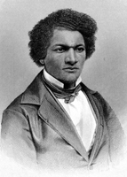
Thank Heaven, I remained but a short time in this distressed situation. I was relieved from it by the humane hand of Mr. DAVID RUGGLES, whose vigilance, kindness, and perseverance, I shall never forget. I am glad of an opportunity to express, as far as words can, the love and gratitude I bear him. Mr. Ruggles is now afflicted with blindness, and is himself in need of the same kind offices which he was once so forward in the performance of toward others. I had been in New York but a few days, when Mr. Ruggles sought me out, and very kindly took me to his boarding-house at the corner of Church and Lespenard Streets.
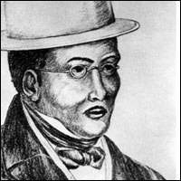
--Frederick Douglas, Narrative of the Life of Frederick Douglass (1845), Chapter XI

