Slavery Through The Eyes of Dred Scott
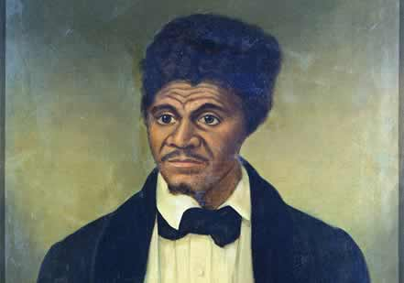
Around 1800, Dred Scott was born in Virginia, owned by planter Peter Blow who then moved his family and their slaves westward to Alabama in 1818 before eventually settling in St. Louis, Missouri in 1830.
In 1832, Scott’s first owner died. He then became the property of Dr. John Emerson, an army surgeon, who took him to Fort Snelling, Wisconsin Territory (present-day Minnesota) in the late 1830s. Shortly Dred Scott “married” Harriet Robinson a teenage slave named owned by the Snelling Indian agent, Major Lawrence Taliaferro. Both Scotts became Emerson’s property and traveled with him over the next several years. They had two daughters, Eliza and Lizzie. Emerson was discharged from the army in 1842 but died the next year unexpectedly.
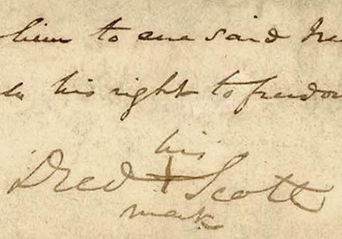Dred Scott’s mark on 1846 freedom suit
In 1846, Dred and Harriet Scott filed separate freedom suits in St. Louis Circuit Court against Emerson’s widow, Irene Sanford Emerson. They lost the first round on a technicality, but won a later round and forced an appeal to the Missouri Supreme Court. During this time, they were helped in their legal efforts by children of Peter Blow, Scott’s first owner from Virginia. They were also hired out as domestic servants in St. Louis. In addition, their separate cases were consolidated under Scott’s name.
In 1852, the Missouri Supreme Court threw out decades of precedent favoring the “once free, always free” doctrine of interstate comity, and ruled in a 2-1 verdict that Dred Scott should remain Irene Emerson’s property. The chief justice noted pointedly, “Times now are not as they were.”
In late 1854, Scott’s case reached the U.S. Supreme Court (as Scott v. Sandford), because John Sanford (Irene Emerson’s brother) was acting as owner of the Scott’s and their two daughters, but the nation’s highest court delayed issuing a ruling on the case until spring 1857. Most observers believed that the court was reluctant to enter the bitter sectional argument over slavery’s future.
Yet on March 6, 1857, Chief Justice Roger Taney read a sweeping 7-2 opinion against Scott that ruled that blacks could not be considered U.S. citizens, that southern states did not have to honor northern laws regarding returned slaves; and that Missouri Compromise of 1820 had itself been unconstitutional because Congress lacked the authority to restrict slavery in the territories.
Despite losing, Dred Scott and his family received their freedom just several weeks after the verdict. Taylor Blow, son of Scott’s first owner, purchased and manumitted them from Irene Emerson (and her new husband, Massachusetts congressman (and abolitionist) Calvin Chaffee). Dred Scott died the next year, a free man. His wife and daughters, however, survived the Civil War.


