Underground Railroad in Myth, Memory & Monuments

“True as a means of destroying slavery, it was like an attempt to bail out the ocean with a teaspoon, but the thought that there was one less slave, and one more freeman,--having myself been a slave, and a fugitive slave--brought to my heart unspeakable joy.” --Frederick Douglass, 1881

FREEDOM QUILTSCourtesy of Lea VanderVelde

How should we remember
the Underground Railroad in American History?

MEMORY
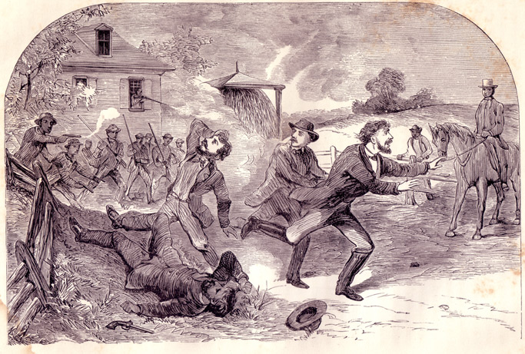
Christiana, 1851: He Died For Law

MONUMENTS
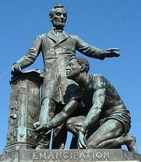
Archer Alexander: The Last Fugitive

