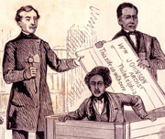
Resurrection of
Henry “Box” Brown

In March 1849, Virginia slave Henry Brown traveled inside a box shipped via Adams Express to escape to freedom. His 24-hour journey from Richmond to Philadelphia was perhaps the most sensational slave escape in American history, but it was just one of several dramatic escape stories at the end of the 1840s. Agents greeting him in Philadelphia included James Miller McKim and William Still.

In May 1854, federal troops arrived in Boston to guarantee the return of a fugitive named Anthony Burns the same week as passage of the Kansas-Nebraska Act. The Burns case galvanized anti-slavery opinion like no other, but it was a Milwaukee fugitive incident that year which led to a landmark Supreme Court decision in Ableman v. Booth (1859) outlawing northern personal liberty laws altogether.
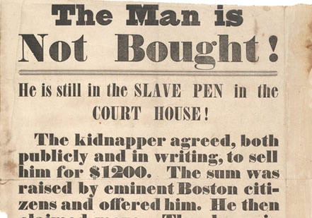
1854 broadside Anthony Burns
After years working for the northern “Subterranean Pass Way,” John Brown took his fight south. He first led a raid into Missouri in 1858 that freed a dozen slaves. Then in October 1859, he launched his failed raid against the federal arsenal in Harpers Ferry, Virginia. His trial polarized the nation and turned the 1860 election into a referendum on its future.

18497
1850 - 1851
1854
1857
1859
In March 1857, the Supreme Court finally ruled against Dred Scott, who had sued for his freedom along with his wife under the doctrine of “once free, always free.” The decision denied blacks citizenship rights, repudiated the doctrine of state comity, and invalidated the Missouri Compromise. Scott was freed anyway in May by the heirs of his first owner.

Scene from Christiana “Riot,” Sept. 11, 1851

John Brown

Dred Scott and Harriet Scott

In September 1850 the Congress passed a tougher federal fugitive slave law as part of the Compromise of 1850. The new law infuriated many northerners. Violent resistance occurred in places such as Boston, Mass., Christiana, Pa, and Syracuse, NY, thereby inflaming sectional tensions to greater heights. One consequence of this new confrontational era was that Missouri slaves Dred and Harriet Scott found their earlier freedom suit victories in circuit court reversed in 1852.

