Daley History 304
Immigration in Early Twentieth Century America
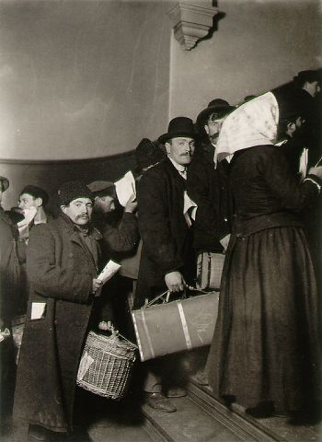
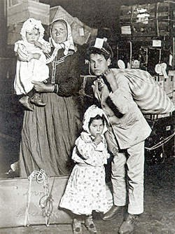

Lewis Hine, “Italian family looking for lost baggage, Lewis Hine, “Climbing into
Ellis Island” 1905 (New York Public Library) America” 1908 (New York
Library)

Lewis Hine took a series of photographs of European immigrants arriving in Ellis Island in the early twentieth century. Hine was interested in documenting the social conditions of the early decades of the century, especially with the American working class and the immigrants from the early 1900s who would become a part of this class.

Questions:
- What do the images suggest about the makeup and status of the families coming to America from Europe in the early twentieth century?
- What do the photographs symbolize, especially in “Climbing into America” about the lives of the immigrants and the ordeals they would face in coming to a new country?
- Hine does not name the people depicted in his photographs. Could this also be representative of how immigrants were treated in America or some of the difficulties they faced in a foreign country?

New York Public Library, Lewis Wickes Hine: Documentary Photographs, 1905- 1938, http://digitalgallery.nypl.org/nypldigital/explore/dgexplore.cfm?col_id=175. (February 2011).

