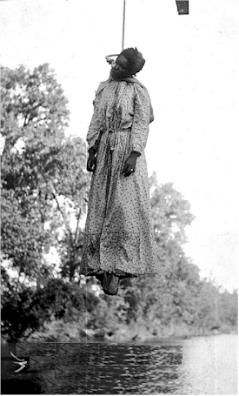

The lynching of Laura Nelson and her son, several dozen onlookers (1911) Okemah, Oklahoma.Gelatin silver print. Real photo postcard. 5 1/2 x 3 ½ Etched in the negative: (1911) copy right, g.h. farnum, okemah. okla\ 2897.”)
This picture is a postcard of the only known female lynching victim, Laura Nelson. Her, along with her 14 year old son were both killed in Okemah, Oklahoma in 1911.
Discussion Questions:
- What does this tell you about the attitudes people held commonly in the South about the act of lynching?
- Why do you think people made postcards of these horrible atrocities?
- What other instances of such violent entertainment are somewhat mimicked in the past? The present?
.

Brent Staples, “The Disciples of Hatred, In Their Own Words and Images.” New York Times, December 22, 2008

