Andrew Fink
Behind the Image Lab
History 304
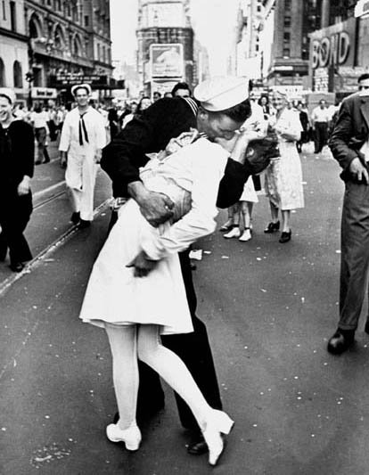
V-J Day in Times Square, 1945
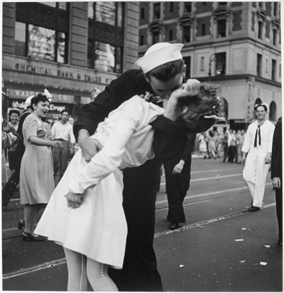
Celebration of V-J Day in New York City August 15, 1945
The image on the left was taken by Alfred Eisenstaedt a photographer for Life magazine. During this celebration he was randomly taking pictures of the crowd and came across a scene of a sailor kissing a nurse. The one on the right is coincidently of the same kissing scene in Times Square, but it was taken by a Navy photographer Lt. Victor Jorgensen. His photo was published the next day in the New York Times but Eisenstaedt’s is the one that has garnered the fame.
Neither Eisenstaedt nor Jorgensen asked the names of these two individuals as they were just trying to get as many photographs of the event as possible. Over the years many individuals have came forward claiming that they are indeed these unknown participants. The stories have ranged from a man on a date grabbing a random nurse to another man kissing every lady he saw and the actual staging of the kiss by its participants.

