Lab Assignment: Ancestry.com

Part 1 Finding and Using Census Records

- Go to Ancestry.com using the Dickinson Library database finder
- Search for records related to one of your ancestors
- Identify at least one census record & copy, paste & crop the image into a one-page handout that contains a brief description of your search, summary outline of your ancestor’s life and/or your family tree and then provide some insight about what the record suggests
- If you can’t find your ancestors (or don’t know them), then choose a famous person from the eighteenth or nineteenth-century and search for their records
- Send the handout to pinskerm@dickinson.edu by Tuesday, Feb. 1 at noon

Part 2 Experimenting With Ancestry

- Browse the search tools and record collections within Ancestry’s Library Edition and try to come up with a demonstration of something creative that would engage students or a general audience with an example of historical thinking (and detective work) in action
- Prepare to present your findings to the class on Tuesday, Feb. 1
- Handouts or other materials are not required but you can create them if you want and have time to do so

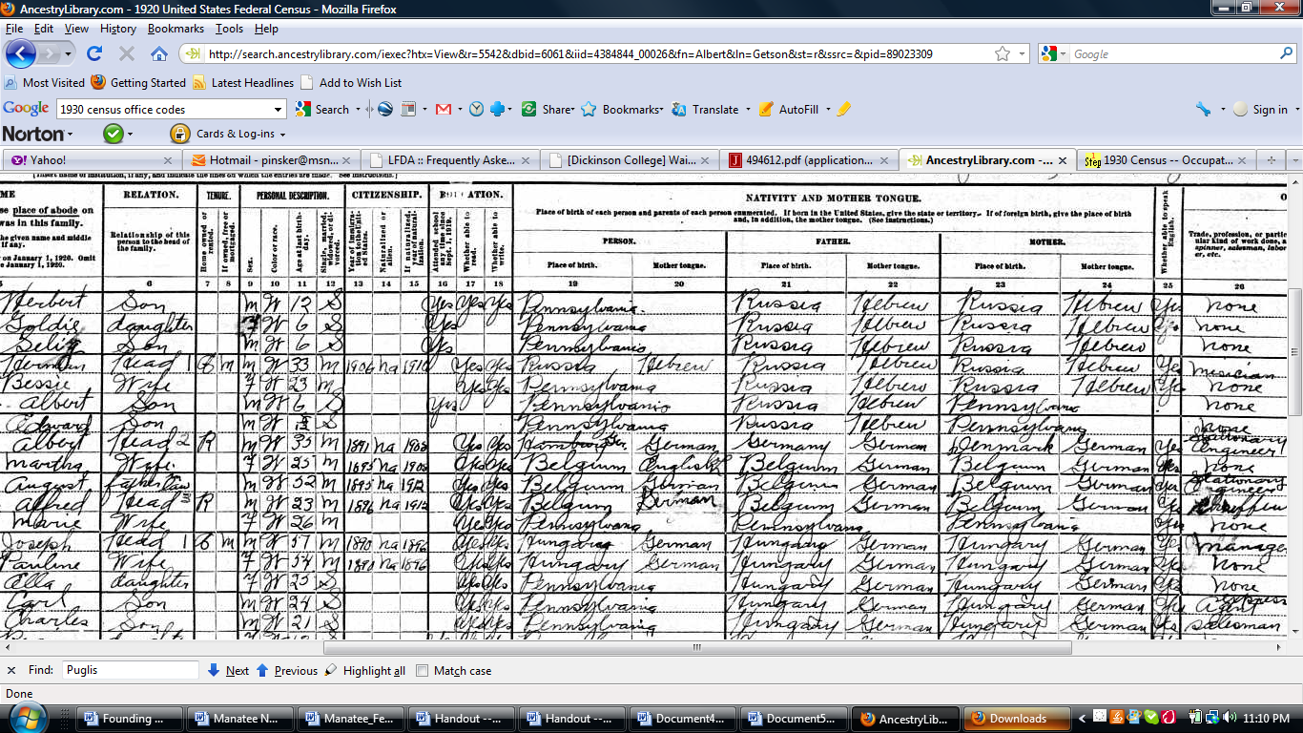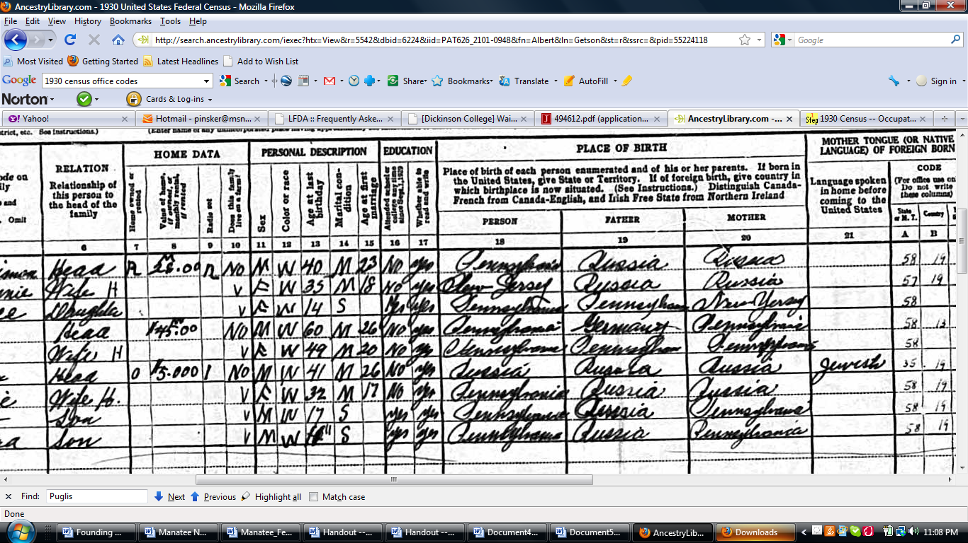
1920 Census 1930 Census

