The Trans-Atlantic Slave Trade
_______________________________________________________________________________________________
General Information: Trade of slaves between Africa and the Americas, which is known as the Trans-Atlantic Slave trade, took place between the 1400’s and the 1850’s. Over the course of these years, Sub Sahara Africa lost roughly half a million people over the course of three centuries. As one can see in the map bellow, the Atlantic Slave trade transported slaves to many different areas such as Europe, the Caribbean, Asian, and North America but primarily South America. The Trans-Atlantic slave trade was largely promoted by the growth of both North and South America and the need for manual labor – most notably on sugar cane plantations. African slaves primarily came from West and Central Africa and their transportation was largely financed by Europe. In particular, the British financed one third of slave voyages. The relatively extensive records of slave voyages and slave trading that still exist allow modern day historians to deduce personal stories and details of this horrific aspect of history.
________________________________________________________________________________________________
Map of Slave Trade Picture:
A.)Major Coastal Regions where Captives Left Africa, all Years
B.) Overview of the slave trade out of Africa, 1500-1900
A.) B.)
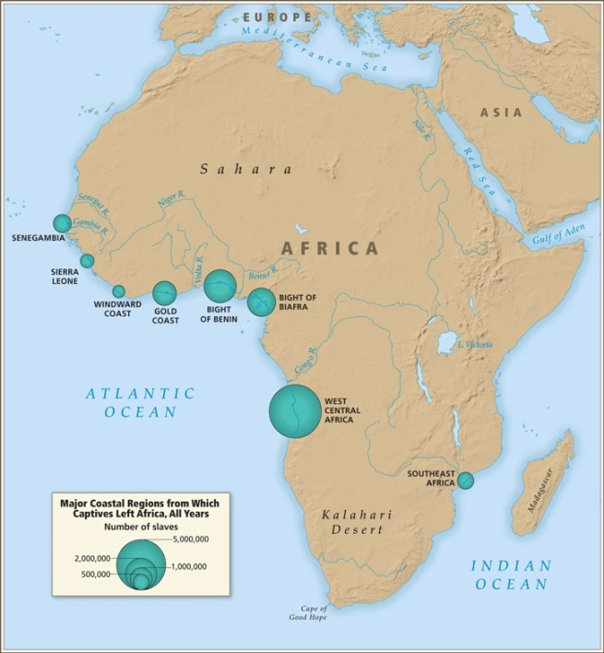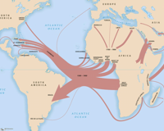
http://www.slavevoyages.org/tast/assessment/intro-maps.faces
_________________________________________________________________________________________________

Olaudah Equiano:
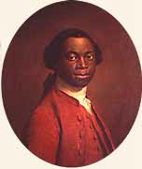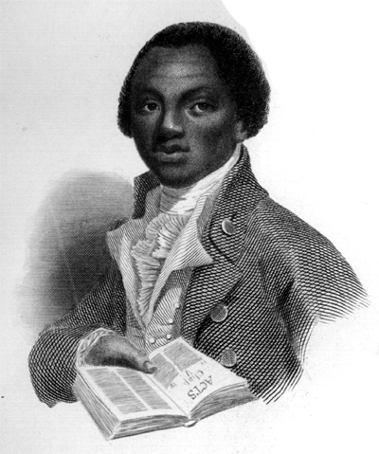
http://www.google.com/imgres?imgurl=http://www.linkstolearning.com/Images/equiano2.

Olaudah Equiano, who is also known by his slave name of Gustavus Vasco, was a Nigerian born African who was kidnapped in the 1750’s and transported to the Caribbean. Towards the end of his life, Equiano became a relatively famous opponent of the slave trade and slavery as a whole. It has long been disputed whether or not he was actually a slave or simply an opponent who created a fictitious account of his life in order to solidify his avocation of slave repatriation. Still, no clear factual evidence to prove this falsity exists, and his autobiography reveals telling insight into the greater horrors of the slave trade. For instance, when he wrote about the inhumane conditions of slave quarters during travel, he wrote,
“The closeness of the place, and the heat of the climate, added to the number in the ship, which was so crowded that each had scarcely room to turn himself, almost suffocated us… The shrieks of women, and the groans of the dying, rendered the whole scene or horror almost inconceivable.”

By using transportation records from the time period that Olaudah Equiano claimed to have been captured into slavery, it is evident that his story appears to be plausible, as there were many Africans being transported to the British Caribbean during the 1750’s and in the years following.

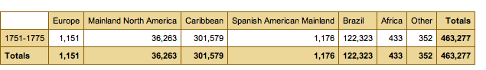
http://www.slavevoyages.org/tast/database/search.faces
List of works Cited

Iliffe, John. Africans: The History of a Continent. Cambridge: Cambridge University
Press, 2007.

Worger, William H. , Africa and the West: A Documentary History. Oxford, Oxford
University Press, 2010.

John Iliffe, Africans: The History of a Continent (Cambridge: Cambridge University Press, 2007),135.
Jeremy Ball.“The Trans-Atlantic Slave Trade” Lecture, February 4, 2010.
William H. Worger, Africa and the West: A Documentary History (Oxford, Oxford University Press, 2010), 57.
John Iliffe, Africans: The History of a Continent (Cambridge: Cambridge University Press, 2007),140-141.

