Kyle Reese
Lab Assignment
The map that I have chosen to use comes from the 2000 US census. It depicts the top reported ancestries in the United States.

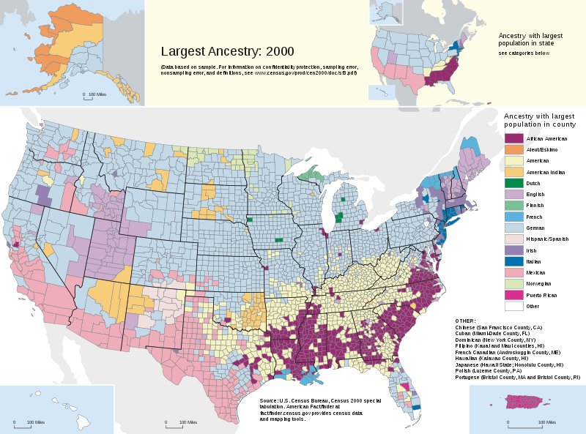
When looking at the map two trends stand out to me, the African Americans and Germans. The density of African American’s living in the south, which can no doubt be attributed to slavery. The Germans seem to be the most spread out of any other nation, literally spanning the country. They also seem to be the predominant country represented in America in the year 2000.

http://en.wikipedia.org/wiki/File:Census-2000-Data-Top-US-Ancestries-by-County.svg

