How to Post to Research Journal
http://blogs.dickinson.edu/hist-304pinsker
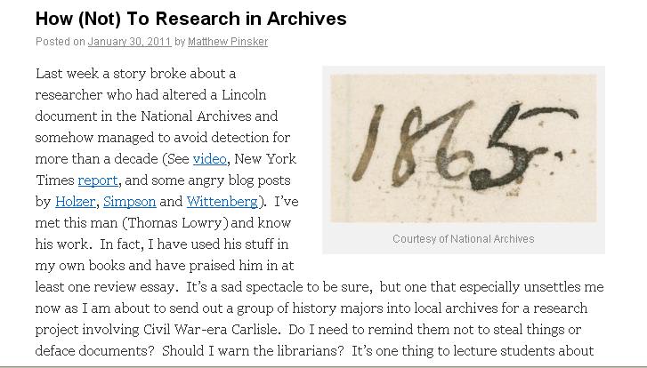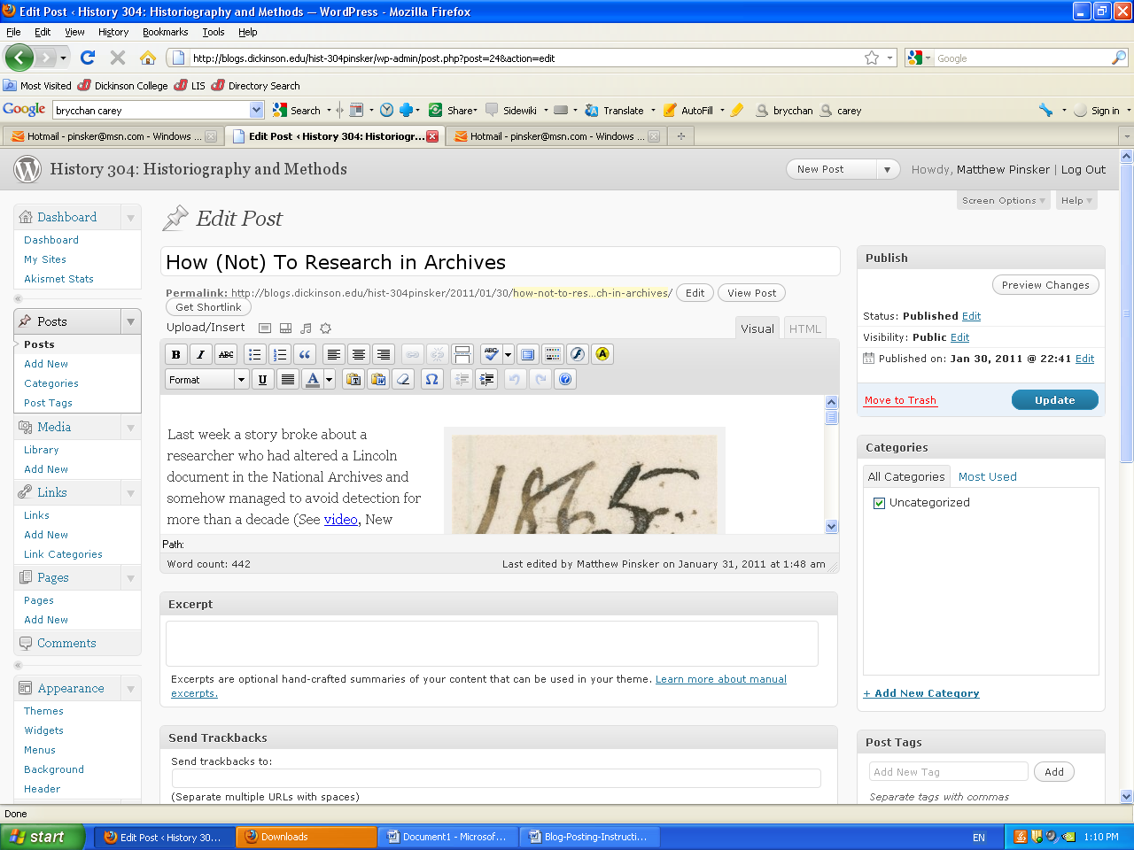

Initial Steps
- Accept course blog registration; change password if necessary; and begin
- Conduct some initial research in archives, microfilm or published sources
- Log in to WordPress site and use Dashboard / New Post to begin

Writing Posts
- Always make sure to lead posts with descriptive title
- You can add images, Word / PDF files or other types of media by clicking on icons on upper-left side of Edit Post interface (above font editor).
  - Images should be in public domain or posted with permission (use “Courtesy of” caption)
  - Right-click images online and then save to your desktop
  - Upload images from desktop
  - You can also custom design image alignment and size
- Keep written text short yet descriptive. Make sure to include basic information such as when and where you were searching; the scope of the search; and a clear catalogue of hits and misses.
- Don’t forget to provide sources and citations –a research journal is like a road map

Reminders
- Don’t forget to hit Update (right-side Edit Post box) to save changes as you work
- If you want to keep your work anonymous (except from Prof. Pinsker), set its Visibility status to Private (upper right corner of Edit Post box)
- Posts marked public will be pushed to the History Department’s Facebook page
- You will need post at least five entries to the research journal by March 11 covering five different types of searches:
  - Manuscript collections in archives
  - Image collections in archives
  - Newspapers on microfilm
  - Newspapers (or other primary sources) in databases
  - Relevant published sources
Tagging Posts
- Tagging is a creative form of indexing. Experiment with tags for your posts.

