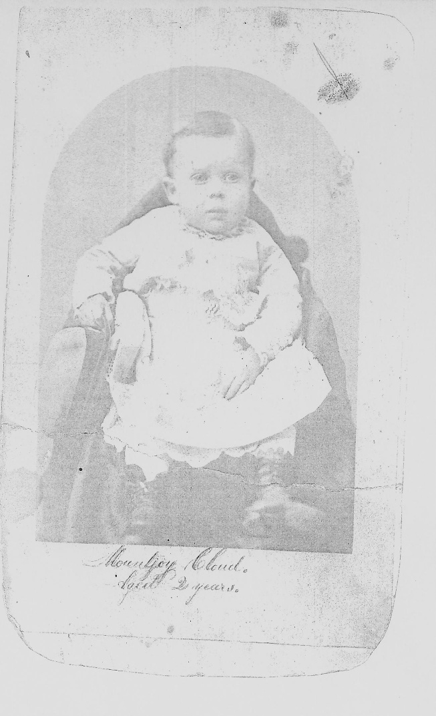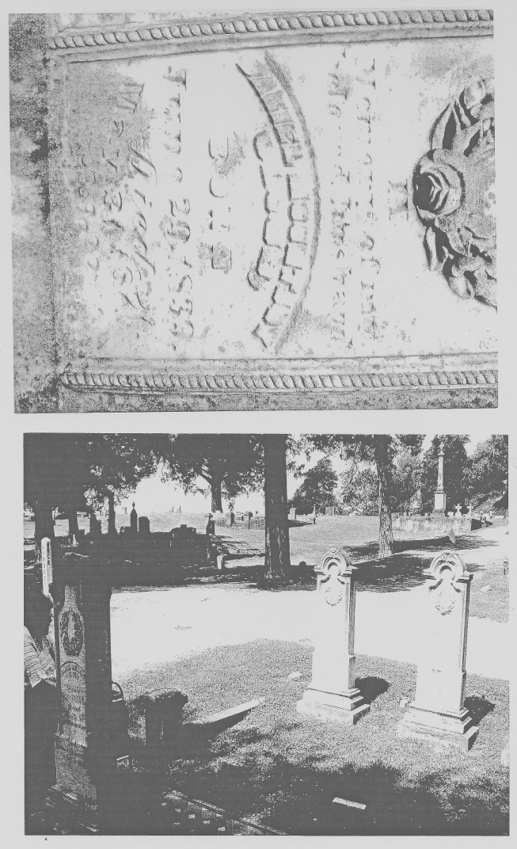
Daniel Mountjoy Cloud, Jr. (1870-1964), Grave of Daniel Mountjoy Cloud, Sr. (1837-1871) Cedar Hill Cemetery, Vicksburg, MS. (Both images are located in the Vicksburg, MS Historical Society Archives).

