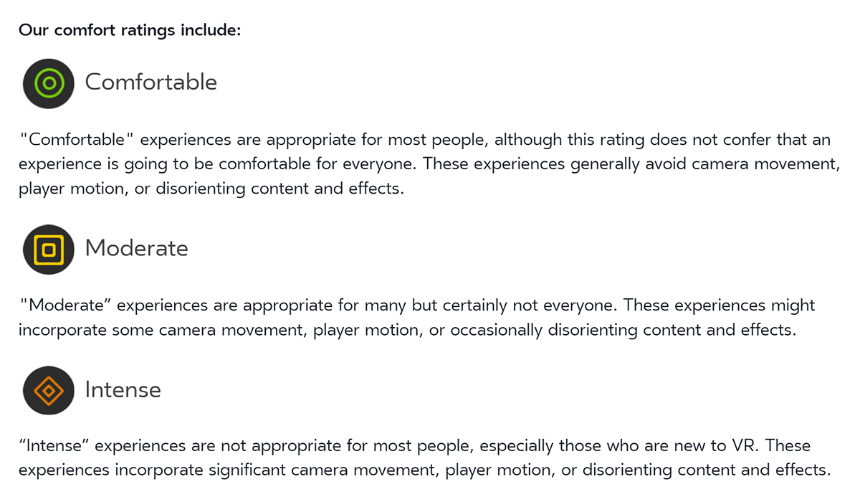

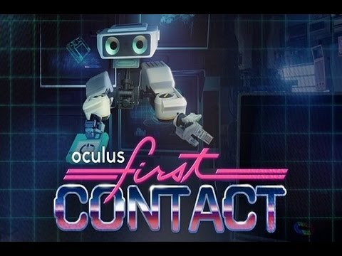 | First Contact is an official Oculus experience designed to be your entryway to Oculus Touch. Experience the magic of ‘presence’ in VR, exploring moments that feel as real as they are fantastically impossible. We've built a magic box full of toys and a robot guide; make a new friend, then touch, tap, bounce, hold and throw things, and play together.  Rated: E  Comfortable
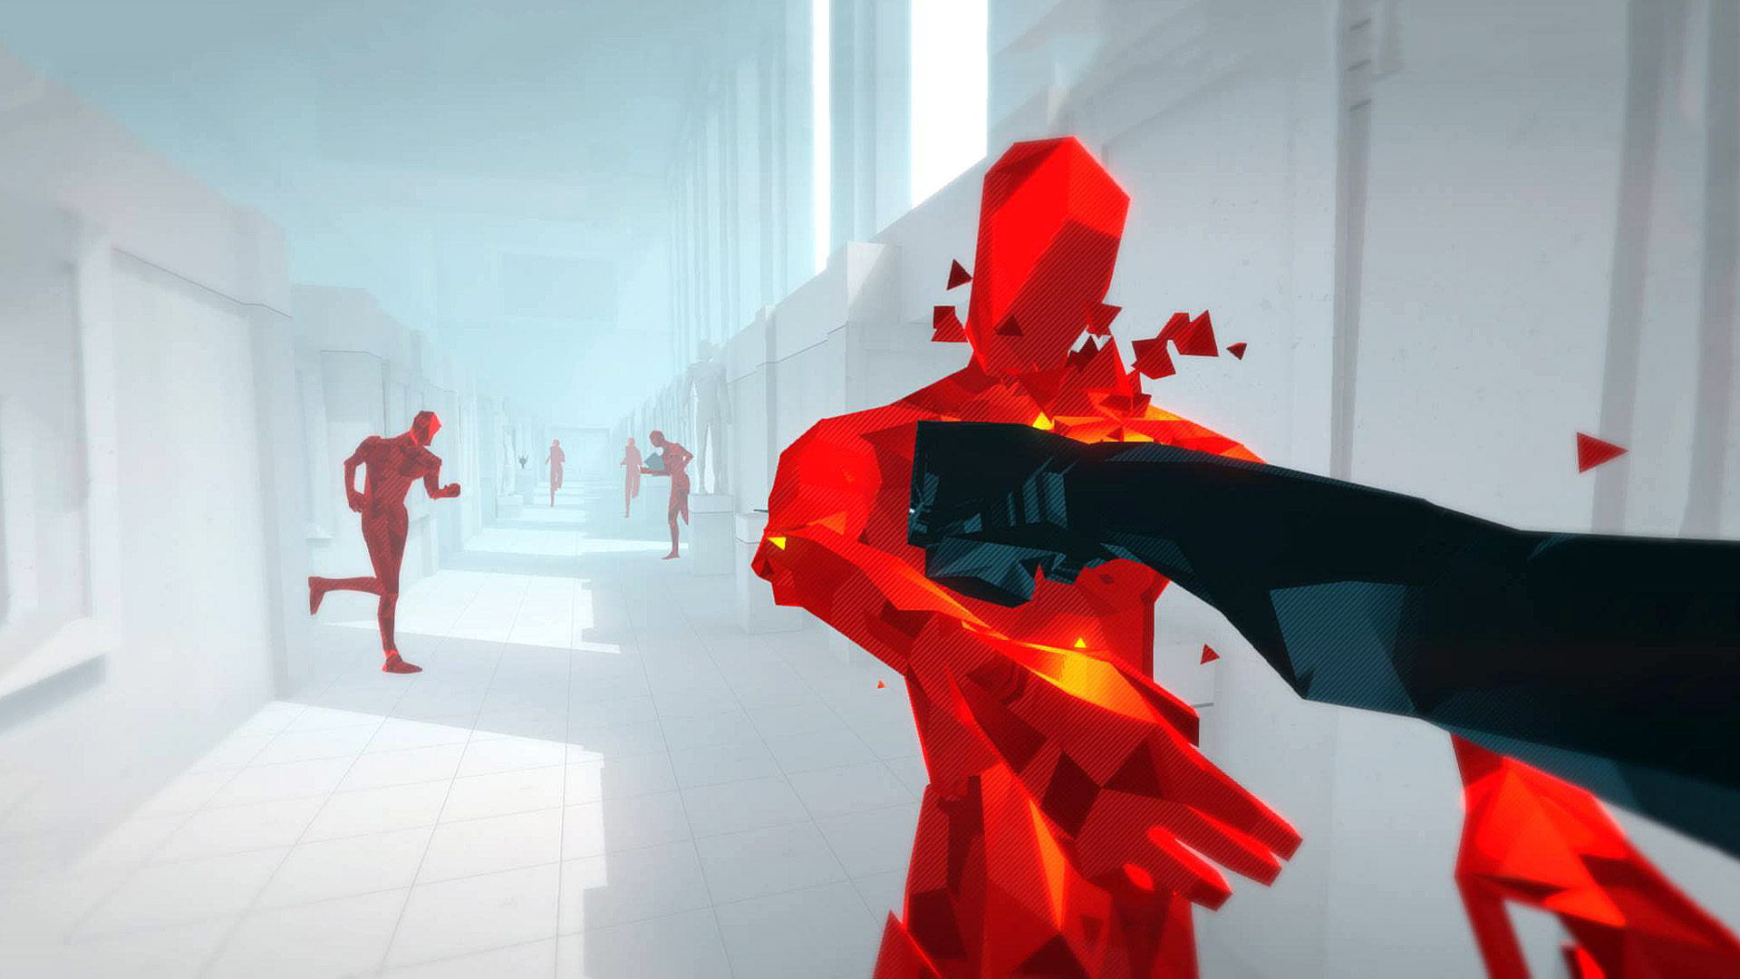 | Superhot VR: Lose track of what’s real. Commit yourself, body and mind. Confront the evocative, elegantly brutal world. Enemies pouring into the room from all sides, a dozen bullets coursing through the air. SUPERHOT VR brings the intensely visceral action of SUPERHOT directly into your head and soul.  Rated: T  Comfortable
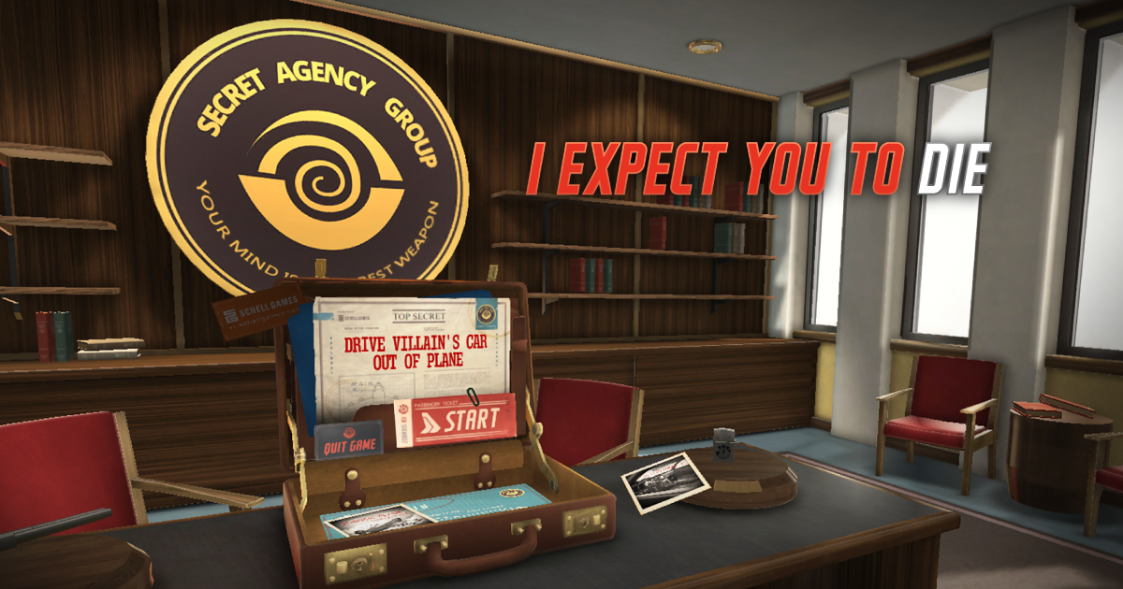 | I Expect You to Die: is a virtual reality puzzle game that places you in the well-polished shoes of an elite secret agent. You must attempt to survive deadly situations in immersive and dangerous locales. Use whatever resources you can find to escape each situation... or die trying.  Rated: E  Comfortable
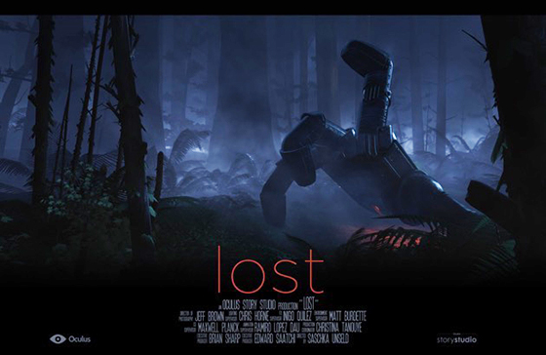 | LOST: From the director of Pixar’s The Blue Umbrella, experience the wonder of an unexpected encounter in a magical forest. An Oculus Story Studio production.  Rated 13+  Comfortable
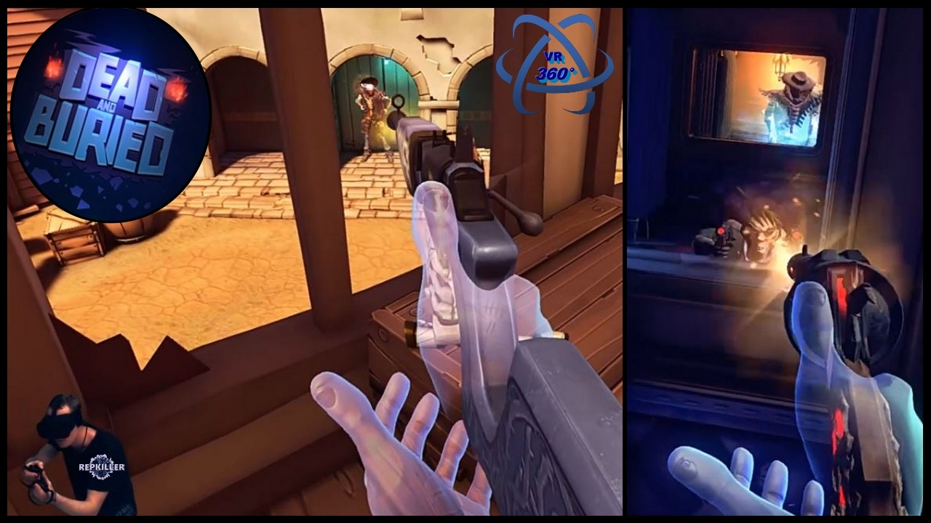 | Dead and Buried: Step into a world full of gunslingers and ghosts in Dead and Buried. Become the best gunslinger in the wild west in this multiplayer action shooter. Battle it out in the old saloon. Rob a runaway train. Team up with other bandits and defend against hordes of ghastly creatures.  Rated: E  Comfortable
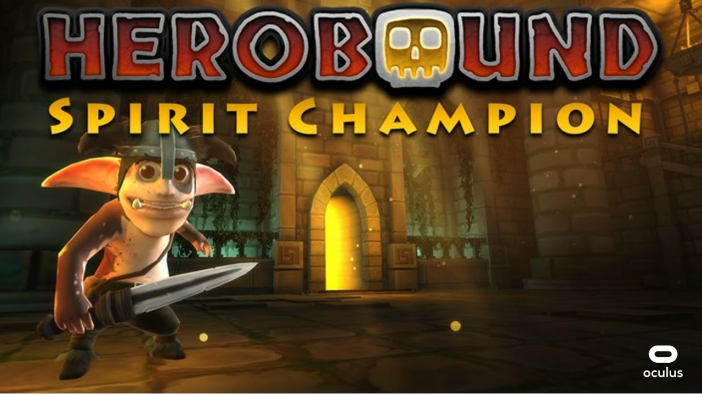 | Herobound: Spirit Champion, you play as the chosen avatar of the Spirit of Life. Explore the 4 natural realms in your quest to free the other Spirits. Each time you free one of the captive Spirits, you are granted a magical stone that imbues you with some of their power.  Rated: E  Comfortable
Jaunt VR: Experience the widest array of premium cinematic virtual reality experiences. Whether on stage with Paul McCartney, exploring the farthest reaches of the globe with ABC News, or base jumping off of the cliffs in Moab, Jaunt delivers breathtaking cinematic VR experiences.

Rated: T
Comfortable

Transition' is an award winning seated virtual reality experience based on the music of Kettel & Secede. A metaphor for death, Transition takes you on a journey from one world into the next.

Rated: E
Comfortable

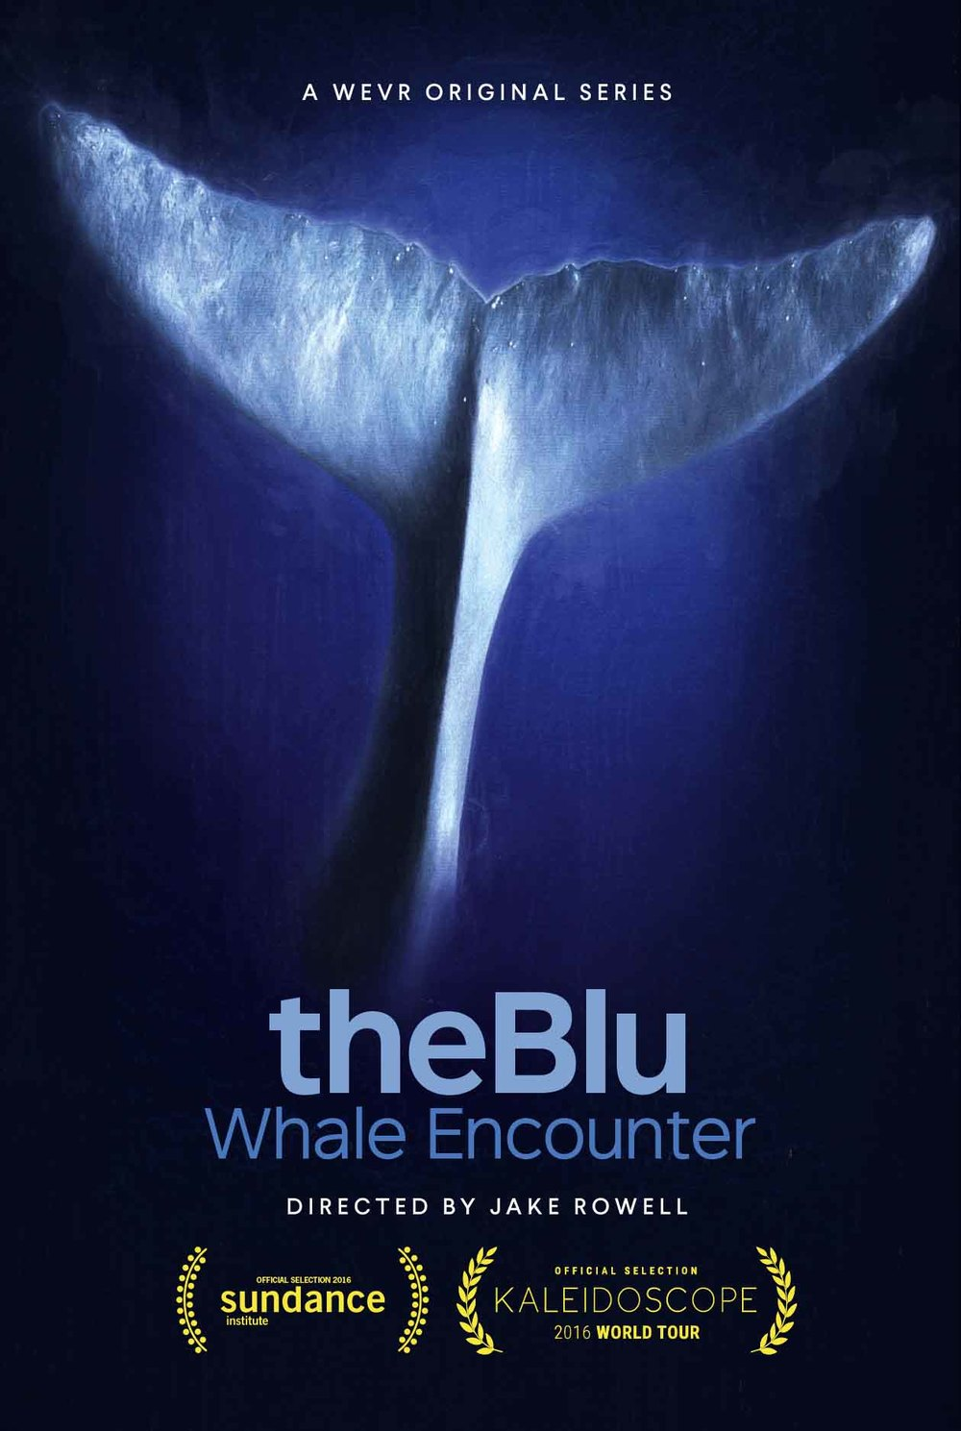 | theBlu: is a deeply immersive VR series that allows audiences to experience the wonder and majesty of the ocean through different habitats and come face to face with some of the most awe-inspiring species on the planet.  Rated:13+  Comfortable
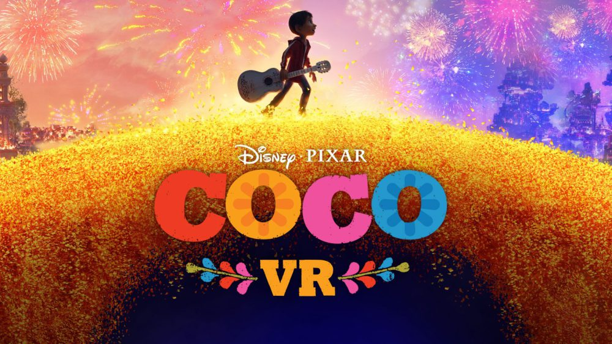 | Coco VR: An adventure into the beautiful Disney-Pixar film, Coco. You can choose either a single or multi-player experience, and follow the magical alebrije into the luminous world of Coco filled with lovable characters and beautiful settings from the film.  Rated: Everyone  Comfortable
Bullet Train VR: Use motion controls in the role of an agent undergoing an infiltration simulation set inside a modern train station. Master the art of teleportation, time manipulation, and close-quarters combat to blast through resistance forces.

Rated: 13+
Comfortable
Sketchfab: Teleport yourself to Rome, hold a beating heart, or walk among dinosaurs. Discover a showcase of explorations through remote places, fantastic creatures, game worlds, cultural heritage, science and other wonders.

Rated: Teen
Comfortable
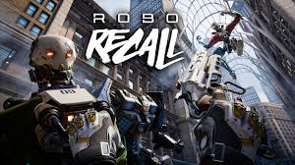 | Robo Recal: A recent barrage of defective, homicidal robots has created openings in RoboReady’s perpetually underfunded and suddenly swamped Recall Department. Thrown into the fray as a Recaller, you must rely on your wits, reflexes and a vast arsenal of weaponry to eliminate the robot uprising.  Rated: T  Comfortable
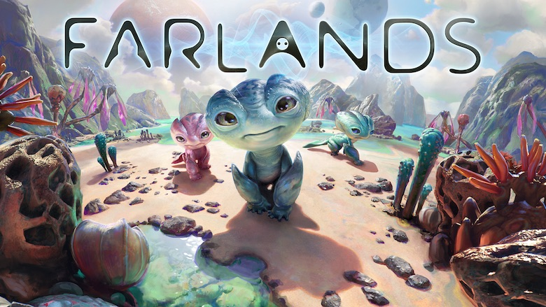 | FARLANDS is a research mission to a little alien planet you can visit every day.  Rated:13+  Comfortable
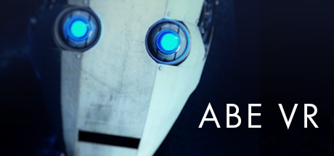 | ABE VR is an intense experience that recreates the horrifying story about a misguided robot seeking the unconditional love of humans…at whatever cost.  Comfortable  Rated: T
Dear Angelica: From Emmy Award, winning Oculus Story Studio comes Dear Angelica, a journey through the magical and dreamlike ways we remember our loved ones. Entirely painted by hand inside of VR, Dear Angelica plays out in a series of memories that unfold around you. An immersive, illustrative short story starring Geena Davis and Mae Whitman.

Rated: T
Comfortable

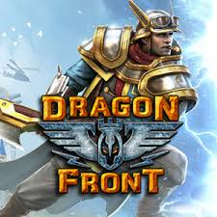 | Dragon Front: This immersive collectible card-battler mixes high fantasy with World War II on a 4x4 grid battlefield that is alive with rampaging giants, intimidating war-machines, and soaring projectiles.  Rated: T  Comfortable
With GoogleEarth VR, you can fly over a city, stand at the top of the highest peaks, walk along new streets, and even soar into space.

Rated: E
Comfortable
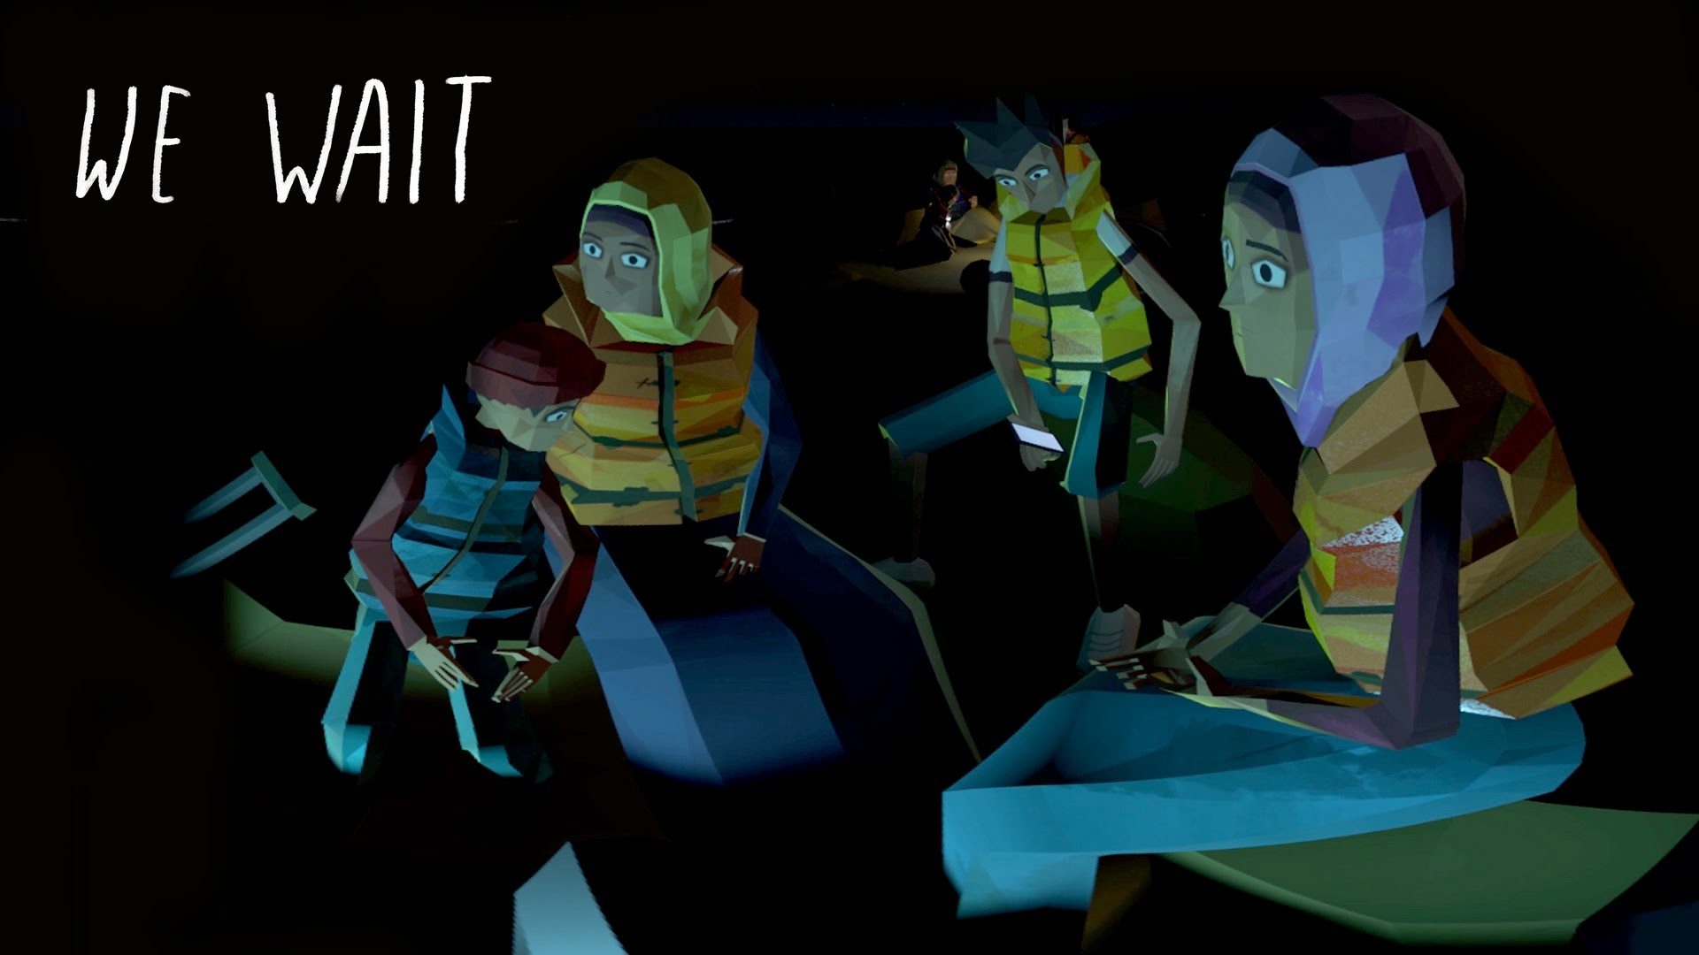 | We Wait: Based on BBC News interviews with migrants, We Wait is a dramatised story transporting you to the heart of the refugee crisis. On a starlit beach in Turkey you meet a Syrian family about to embark on their second perilous attempt to cross the sea to Greece.  Rated E  Comfortable
Henry: It’s Henry’s birthday, but where are his friends? Narrated by Elijah Wood, Henry is an Emmy award-winning VR film that takes you inside the home of a lonesome but lovable hedgehog whose birthday wish changes everything.

Rated: E
Comfortable

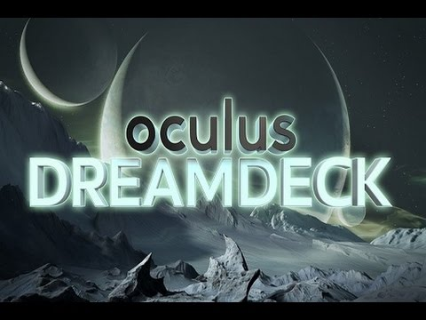 | Oculus Dreamdeck: Dreamdeck transports you to impossible places and magical worlds.  Rated: 13+  Comfortable
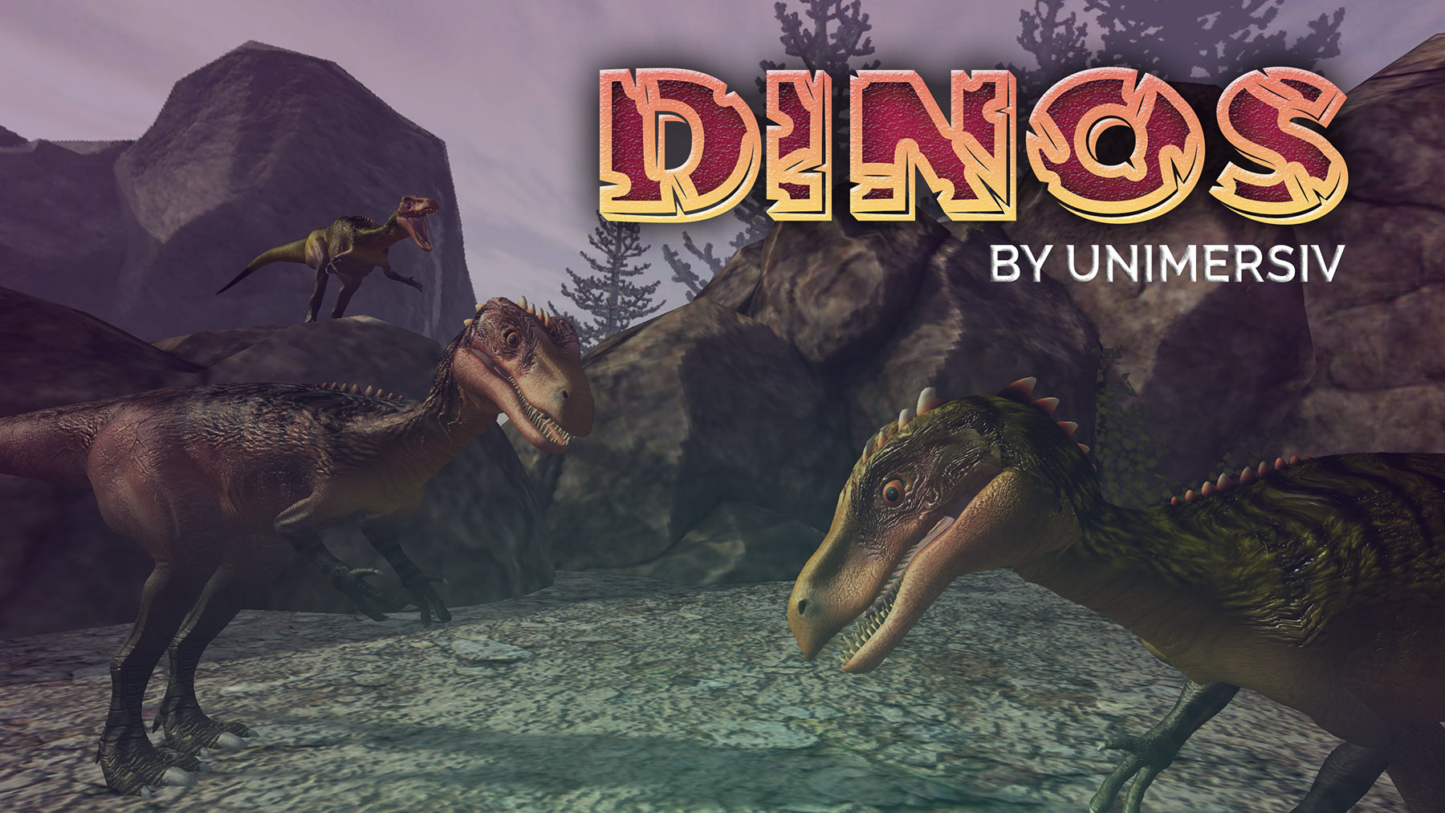 | Dinos by Unimersiv: Learn about your favorite dinosaurs in VR  Rated: E  Comfortable
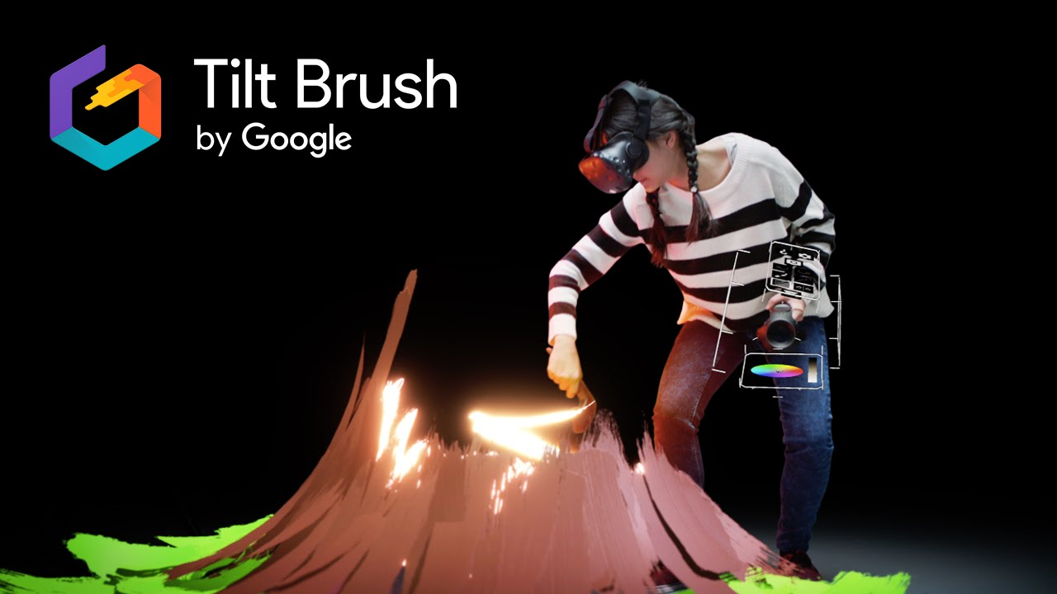 | Tilt Brush: lets you paint in 3D space with virtual reality. Unleash your creativity with three-dimensional brush strokes, stars, light, and even fire. Your room is your canvas. Your palette is your imagination. The possibilities are endless.  Rated: E  Comfortable
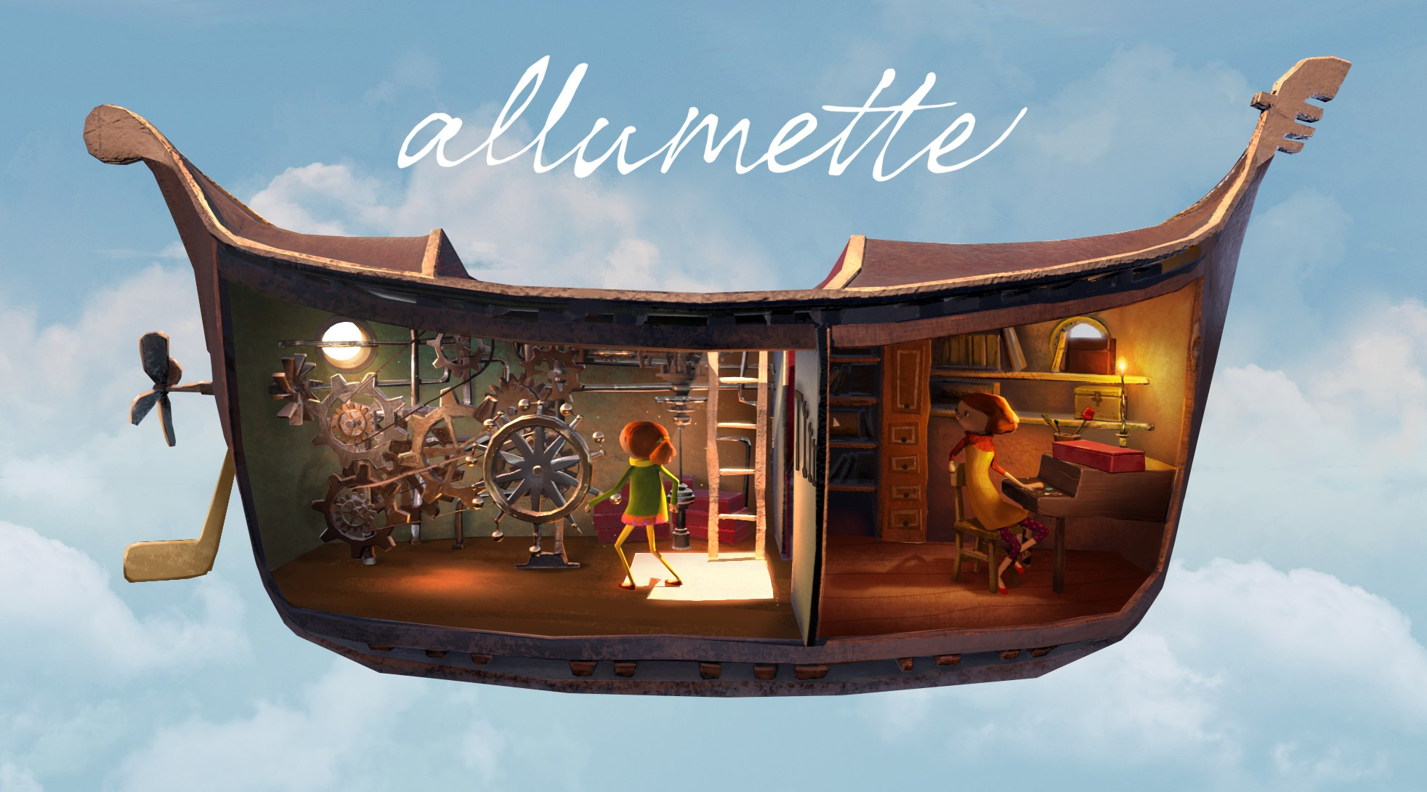 | Allumette: tells the story of a young orphan girl who lives in a fantastical city in the clouds. After enduring tragedy, she grasps at hope for her future. Allumette is an account of the love a mother and daughter have for one another.  Comfortable  Rated 10+
Silver TV: Watch live esports in fully immersive 360° VR! Catch some of the biggest tournaments of the year for CS:GO, League of Legends, and more. Return for daily match highlights and replays capturing the best moments - and all in 360° immersive video.
Comfortable
Rated:T
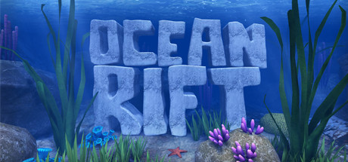 | Ocean Rift: Ocean Rift is the world's first VR aquatic safari park. Explore a vivid underwater world full of life including dolphins, sharks, turtles, orcas, sea snakes, rays, whales, manatees, sea lions and even dinosaurs! Ocean Rift is divided into 12 unique habitats.  Comfortable  Rated: E
Discovery: For more than 30 years, Discovery has told stories like no one else — transporting you to places you didn’t know existed and sparking curiosity at every turn. Virtual Reality can take you to new worlds like never before, immersing you in time, space and story.
Comfortable
Rated: E
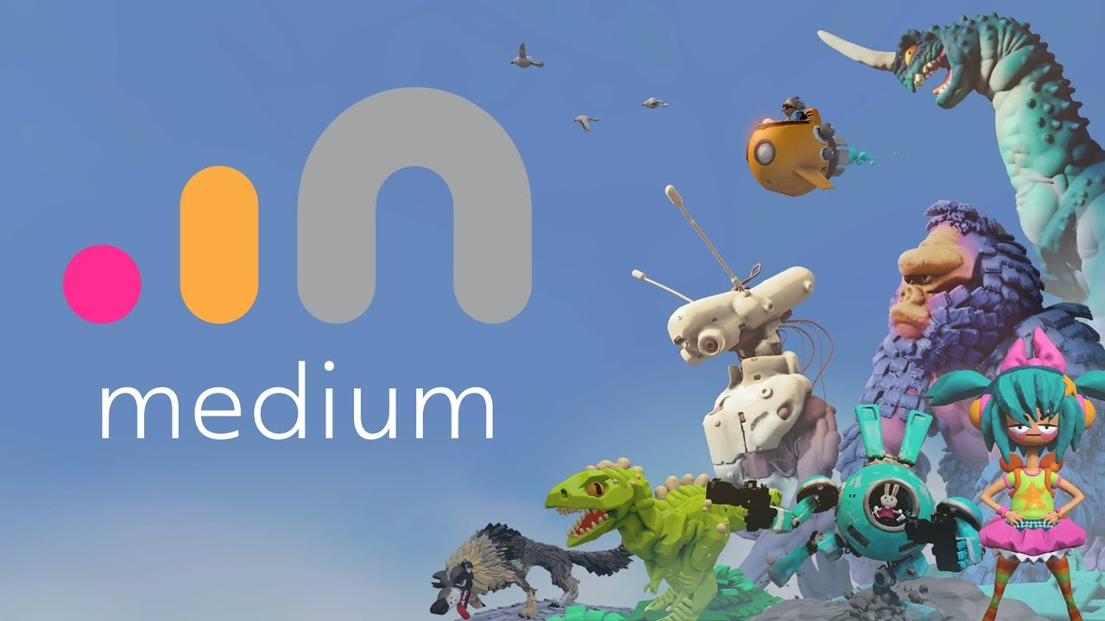 | Oculus Medium: Oculus Medium is an immersive VR experience that lets you sculpt, model, paint, and create tangible objects in a VR environment. Medium lets you create expressive works of art.  Comfortable  Rated: E
Bigscreen Beta: is a social virtual desktop app that lets you use your computer in VR on massive virtual screens. Hang out in virtual worlds and collaborate with coworkers, play PC games & watch a movie with friends, or relax by the campfire and chat.
Comfortable
Rated: E
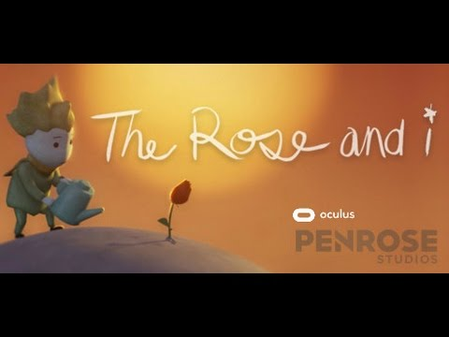 | The Rose and I: An immersive, animated VR film. “The Rose And I” is about loneliness, friendship, love, and loss. Come meet a lonely Rose living in the unlikeliest of places, and join her as she transports you to a brand-new universe.  Comfortable  Rated: E
Boulevard: brings art, architecture, and culture to people around the world. Partnering with leading museums and cultural sites, Boulevard gives immersive access and revolutionizes the way the world looks at the arts. Boulevard is reshaping the landscape of storytelling and bringing history to life for anyone, anywhere, anytime.
Moderate
Rated: E
The Body VR: s an educational experience that takes the user inside the human body. Travel through the bloodstream and discover how blood cells work. Enter one of the billions of living cells inside our body and learn how the organelles work together to fight deadly viruses.
Moderate
Rated: E
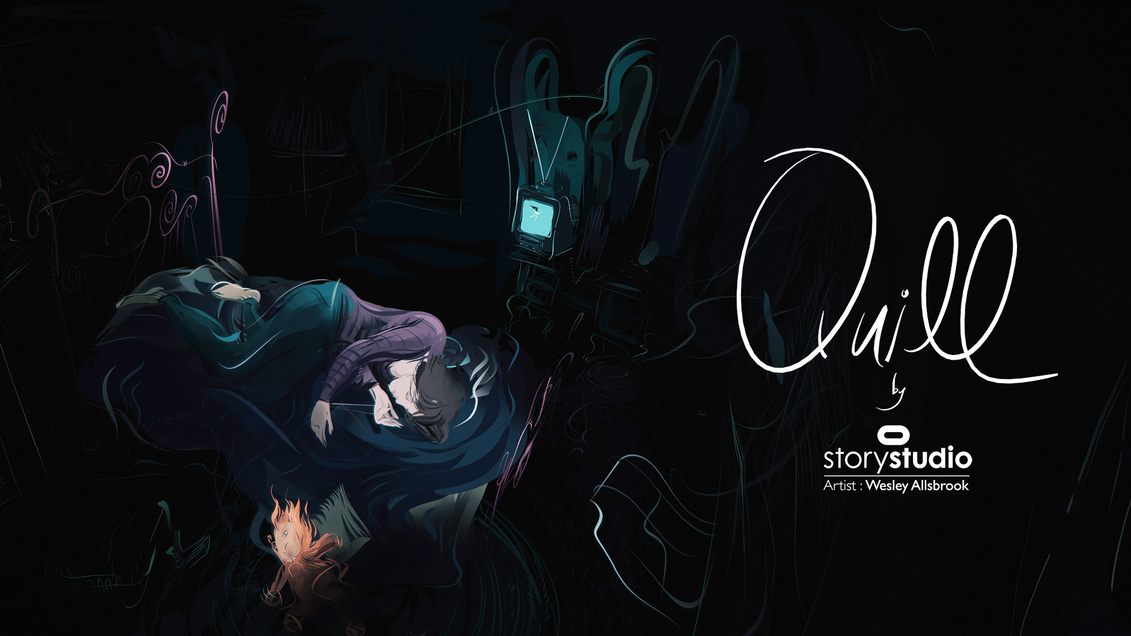 | Quill:is the VR illustration tool.Quill allows users to paint in virtual reality on an infinitely scalable canvas - with rich color tools and different brushes. Quill is designed to be expressive, precise and to let the artist's "hand" come through clearly.  Moderate  Rated: E
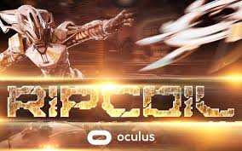 | Ripcoil: Enter a futuristic gladiatorial arena packed with rabid fans as you face off against networked opponents in a disc throwing duel. Deftly position your hover board as you reach out with your Touch controllers to launch, catch and punch the speeding, spinning Ripcoil disc.  Moderate  Rated: E
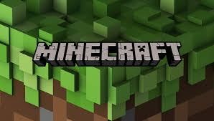 | MineCraft: Get right inside the world of Minecraft with virtual reality. Build, explore and battle mobs - do all the things you know and love - but from a fresh perspective. With a VR headset on, coming face-to-face with monstrous mobs takes on new meaning; creeping into dark caves inspires even greater trepidation thanks to 3D audio.  Moderate  Rated: 10+
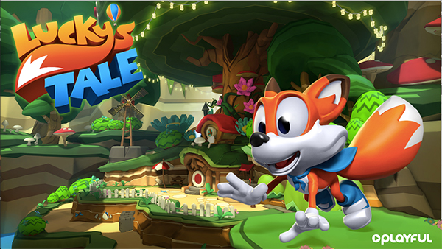 | Lucky’s Tale: is a delightful platforming adventure game designed exclusively for the Oculus Rift. Join Lucky as he runs, jumps, climbs and spins his way through a bright, colorful world filled with thrilling challenges, wacky creatures, and all the shiny things a little fox could ever want!  Moderate  Rated: E
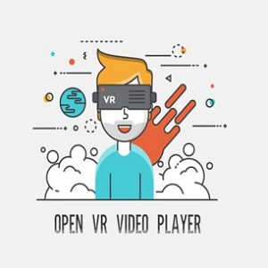 | Open VR Video Player: FREE video player for Oculus Rift  Moderate
Mountain Goat Mountain: is a fast arcade game, where you climb the highest and most treacherous mountain ever seen by a goat. JUMP up the mountain. Jump up the mountain. DODGE lots of things that when falling will most likely squish you. Collect different Goat Hats to travel to different environments.

Moderate
Rated: E
Chernobyl VR Project: is a virtual experience which allows you to visit the ghost town of Pripyat and learn about its history. It is a tribute to the victims of the disaster. Together, let's find out the future that was lost.

Intense
Rated: E
The Climb: Scale huge heights and feel the exhilaration of extreme free solo climbing. Explore and enjoy the view or compete for the fastest times on leaderboards with Touch or gamepad controls.

Intense
Rated: E
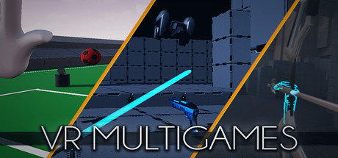 | VR Multigames: This package includes 3 minigames, DRONE ASSAULT A lightsword game with drones, LAST STAND, the only thing you have is your bow, use it to survive as much time as possible,GOALKEEPER SIMULATOR A goofy minigame where you are a goalkeeper and defend the goal with huge telescopic hands  Unrated  Rated: T
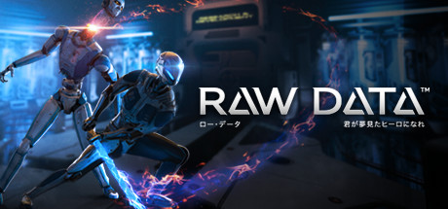 | Raw Data: co-op action gameplay, intuitive controls, and gripping sci-fi atmosphere will immerse you within the surreal environments of Eden Corp.  Moderate  Rated: T
 | Dungeons & Treasure: an endless fast-paced action adventure. You progress through different environments with unique enemies, bosses and challenges like traps and minor puzzles.
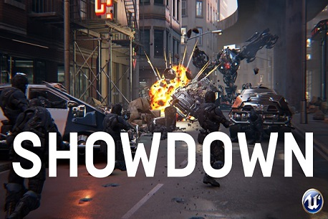 | Showdown: action cinematic that takes you through a guns-blazing scenario in slow motion.  Unrated  Rated:13+
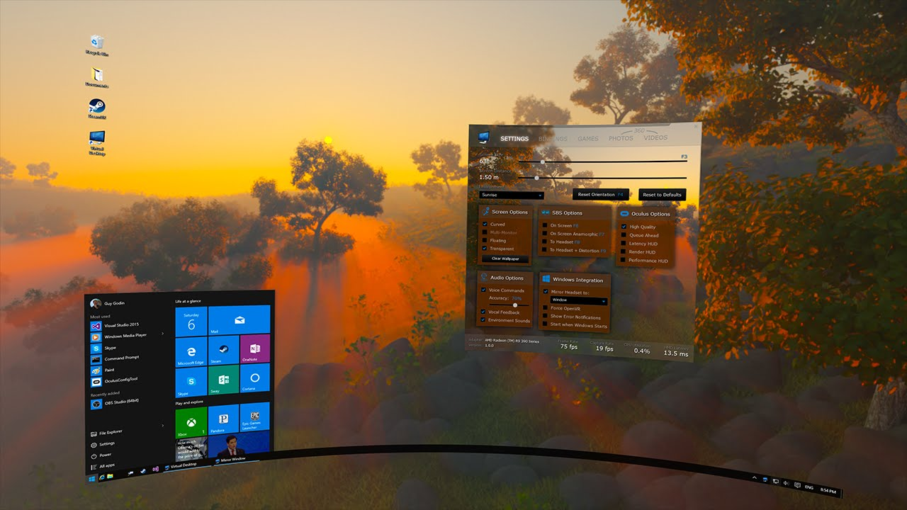 | Virtual Desktop: an application that lets you use your computer in VR  Comfortable  Rated: E
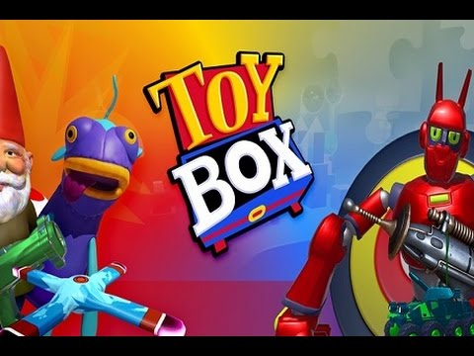 | Toy Box: fan-favorite demo experience, is now available to play at home! This is one of the best ways to showcase the power of social interaction in VR. Light fireworks, drive tanks in zero gravity, and interact with a variety of gadgets and games with a friend—wherever they are.  Unrated  Rated: E
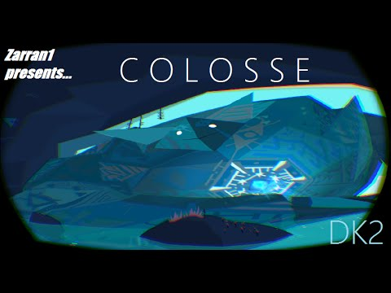 | Colosse: A Story in Virtual Reality: a real-time virtual reality storytelling experiences the story of the long lost Great Spirits known as the COLOSSE explores themes of fear, power and respect.  Unrated  Rated: E

