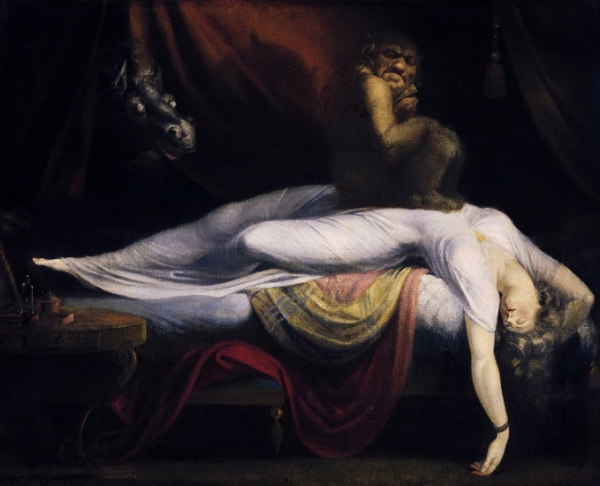
Professor Sarah E. Kersh
kershs@dickinson.edu
sarahkersh.com

Office Hours:
Thurs 10-11:30, Fri 8:30-10:00 and by appt
Office phone: 717-254-8952
Office: Historic President’s House, 6B
NOTE: My office is located on the 2nd floor, which is only accessible by going upstairs. This building does not have an elevator. If this is problematic for you, I will gladly arrange to meet you on the main floor or at another, more accessible, location. Please let me know.
The Nightmare (1781) by Henry Fuseli
Course Description
Evil alter-egos, soul-sucking vampires, and detective thrillers—all have their roots in the literature of the nineteenth-century. From villains such as Dorian Grey to Dracula and the Hound of the Baskervilles, the sensational literature of the Victorian era sought to stimulate the mind and awaken emotion. This course will examine how monsters, mad scientists, and secret identities rose in the public imagination alongside of a rapidly-changing nation. The nineteenth century saw unprecedented growth of industry and leaps in scientific discovery; new and rapid global communication as well as transport; tenuous relationship of commodities, consumers, and economic stability; as well as changing conceptions of class, gender, and what it meant to be an individual.

Course Materials
The following texts are required for the course and are available at the college bookstore:
- Lady Audley’s Secret by Mary Elizabeth Braddon (ISBN: 978-0-14-043584-8)
- The Hound of the Baskervilles by Arthur Conan Doyle (ISBN: 978-0-14-043786-7)
- Goblin Market and Other Poems by Christina Rossetti (ISBN: 978-0-486-28055-4)
- Dracula by Bram Stoker (ISBN- 978-0-14-143984-6)
- The Strange Case of Dr. Jekyll and Mr. Hyde by Robert Louis Stevenson (ISBN: 978-0486266886)
- Additional readings are available on our class website unless otherwise specified in the syllabus.
- Writing Analytically, 7th ed by David Rosenwasser and Jill Stephen (ISBN: 978-1337284448)*

*There is a copy of Writing Analytically on reserve at the library. If you chose it use that copy, you must photocopy the pages assigned for class so that you can have them with you in class.

Course Objectives
As per the English Department’s Learning Goals, by the end of this course students will be practiced in:

1) the ability to read texts closely in a sensitive way (based on the presence of germane summary, accurate paraphrase, and/or careful attention to patterns and details of language).

2) the understanding of the relationship(s) between text and context in the generation of meaning (“context” to include at least one of the following: portions of a text other than the one under prime examination, other texts, literary genres, history, biography, literary theory).

3) the ability to formulate a powerful critical argument (characterized by an arguable thesis, the convincing marshaling of evidence, and grammatically and mechanically correct prose).
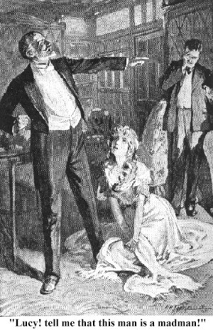
Attendance:
This class is a workshop/seminar and therefore depends on the participation of its members. Failure to attend undermines the class as a whole. Attendance, therefore, will be a substantial part of your participation grade. You may miss up to three class periods without penalty. I do not distinguish between “excused” and “unexcused” absences, so please use these judiciously. I strongly advise you keep at least one free absence “in the bank” in case something comes up. If you miss the class for any reason, you are responsible for what went on in the class, including changes of assignments. I will not answer emails asking me to describe what went on in class. You are responsible for contacting one of your classmates to find out what went on, including any changes of assignments. If you miss more than three classes your grade will decrease per missed class. If you have extenuating circumstances, please contact me as soon as possible.

Please make an effort to be on time. Class begins promptly and if you are more than ten minutes late, I will record you as absent. If you have a reason that may cause you to be late from time to time, please let me know. (If you are a student athlete or member of a student group that requires you to miss class for a university-sanctioned event, please let me know as soon as possible.)
Lady Audley's Secret; Tinsley Bros. 1862

Requirements and Grading
Beyond participation, your grade will be based on weekly response paper and two more formal papers. The relative weight of each component is as follows:

Attendance and Participation | 15%
Midterm Exam | 15%
Final Exam | 20%
Blog Posts, comments, and other writing | 30%
Final Paper | 20%

Final letter grades will be assigned in the following way:

A = 93-100 | B- = 80-82 | D = 60-69
A- = 90-92 | C+ = 77-79 | F = 0-59
B+ = 87-89 | C = 73-76
B = 83-86 | C- = 70-72

A Note About Grades:
If you would like to discuss graded work, please take at least two days to review my comments, along with the grading criteria for the assignment. While I don't negotiate grades, I am happy to discuss strategies for improving your writing.
Extra Credit:
If you attend any Dickinson College screening, workshop, or lecture and write a 1-2 page reflection stating how the event related to this class and what was interesting about it for you, I will award 1 point extra credit. You may complete up to 5 extra credit reflections. These points will be added to your final paper grade at the end of the semester. I will reject any reflection I feel is insufficient or unsuitable.

Participation:
I also expect you to read the assigned material and prepared to ask questions and offer opinions about it during class. Attendance alone with little or no contribution will only earn you approximately a C in participation. I recognize that some students are hesitant to speak in front of class. If this is the case, please come talk with me during office hours early in the semester.

Technology:
The point of my course technology policy is to create a distraction-free environment for you and the people sitting near you. Therefore, during class time, you may only use laptops and tablets for e-readings and taking notes. If you are using technology appropriately, you will spend far more time looking at your classmates than you do looking at the screen. You may not have Facebook, games, or internet sites open during class, and doing so will end your computer/tablet privileges. We recommend you switch off your wireless connection to help you avoid unwanted distractions. Please turn your phone to silent and enclose it completely in your bag away from your sight and touch. Translation devices are allowed if you speak to me first. Per Pennsylvania state law, the use of recording devices is not permitted unless specifically cleared for accommodation purposes.

Deadlines:
Deadlines are firm. Unless you have asked for and received prior permission to extend the deadline or you have a signed medical excuse, late assignments will lose one grade increment per day late. I cannot accept assignments more than one week late.

“How can I know what I think until I see what I say?” – E.M. Forster

Blog Posts:
You will complete a number of blog posts over the course of the semester as well as comment on other posts made by your classmates. These posts will be in response to prompts handed out in class or of your own direction. Over the course of the posts, I expect you to engage with the readings and discussions and not simply summarize them. I also expect you to make connections to other sources, media, and class texts so please add quotations, images, links, videos, etc. that relate to the week’s topics and your interpretation of them. We will explore these skills in class.

Privacy
I request you all create a screenname under which you blog for our class. Part of our class will be trying out new and different perspectives and positions. I recognize that these positions can change and grow; by using screennames we give ourselves the room to experiment. I am happy to remove any blog posts at the end of the term and/or you may remove your own writing. I ask that you let me know.

Norman M. Eberly Writing Center:
Writers of all levels and abilities need feedback in order to develop their ideas and grow as writers. Dickinson’s trained writing tutors can help you generate ideas, begin drafting, revise a rough draft, figure out your professor’s preferred documentation style, understand and respond to professor feedback, edit your writing – among other things. You can walk in or call and make an appointment at (717) 245-1620 (or 245-1767 for foreign language writing). For more information about hours and procedures, visit the web: http://www.dickinson.edu/academics/resources/writing-program/content/Writing-Center/

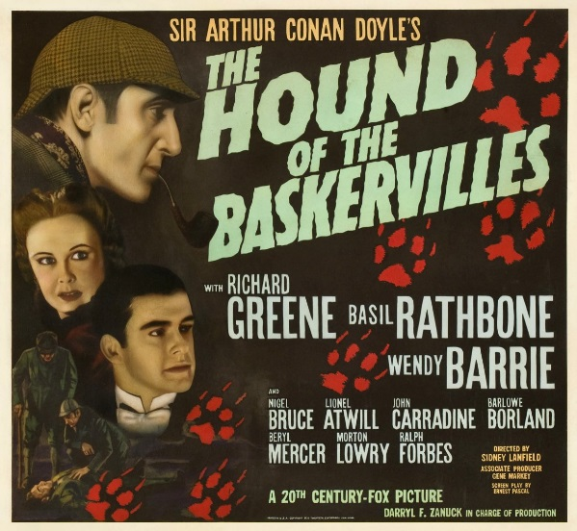
Academic Integrity
With respect to all assignments in this course, I expect you to do your own work. You are certainly encouraged to discuss course content and readings with your fellow classmates, but your work in papers must be your own. Regarding outside sources, you will need to cite all of your sources. We will discuss ways of doing this before your writing assignment is due. If you have any questions about what constitutes cheating or plagiarism, please feel free to ask. From Dickinson College's Community Standards:

Respect for ideas — our own and others’ — is a hallmark of academic integrity. We show respect by acknowledging when we have used another’s words or ideas in our work. We expect others to acknowledge when they use our ideas or words in their work. Students are expected to do their own work on quizzes, papers, examinations, class assignments, etc. (https://www.dickinson.edu/download/downloads/id/963/community_standards )

Accommodations
I am committed to including all students in this course and am happy to discuss accommodations with students, provided that this conversation happens early in the semester and definitely before any papers/projects are due. From Dickinson College’s Disability Services:

Dickinson values diverse types of learners and is committed to ensuring that each student is afforded an equal opportunity to participate in all learning experiences. If you have (or think you may have) a learning difference or a disability – including a mental health, medical, or physical impairment– that would impact your educational experience in this class, please contact the Office of Disability Services (ODS) to schedule a meeting with Director Marni Jones. She will confidentially discuss your needs, review your documentation, and determine your eligibility for reasonable accommodations. To learn more about available supports, go to www.dickinson.edu/ODS , email DisabilityServices@dickinson.edu, call (717) 245-1734.

Other Needs:
I am committed to providing equal educational opportunity to all students. If you have a concern or issue regarding this class, your ability to participate in it, or the material we are covering, please stop by my office hours or email me to set up an appointment. The sooner we can talk about your concerns, the better I will be able to help you negotiate a solution. Please note I do not usually check email after 5:00 pm or on weekends.

Class Contacts:
If you miss class for ANY reason it is YOUR responsibility to contact another member of the class to see what you may have missed. Please make sure you have at least three contacts:

- name: ______________________________ cell: _________________________

- name: ______________________________ cell: _________________________

- name: ______________________________ cell: _________________________
Monsters & Madness: Secret Lives in Victorian Literature
English 101-04: Dickinson College, Fall 2018
M/W/F 10:30-11:20; Denny 211
Class website: www.blogs.dickinson.edu/secretlives (password: Kersh)

*NOTE: This COURSE SCEHDULE MAY CHANGE*
While I intend to stay as faithful to this syllabus as possible, I reserve the right to make changes at any time to accommodate the evolving needs and interests of the class. Changes will always be announced in class prior to the date they take effect. Absent students are responsible for any changes announced in class. Please see our class website for more up-to-date information

Course Schedule: Reading and Writing assignments are due in class on the date they are listed. (red assignments are writing assignments or exams)

Week 1
September 3
~Class Introduction
September 5
~ Robert Browning’s “My Last Duchess”
~ Writing Analytically, 7th ed pp1-7 and pp14-15
September 7
~ Lady Audley’s Secret, Vol I; chapters: 1-2
~ complete: Writing Questionnaire
Week 2
September 10
~ pp 16-32 in Writing Analytically, 7th ed
~ Lady Audley’s Secret, Vol I; chapters: 3-6
September 12
~ Lady Audley’s Secret, Vol I; chapters: 7-13
September 14
~ Lady Audley’s Secret, Vol I; chapters: 14-18
Week 3
September 17
~ Lady Audley’s Secret, Vol I; chapters: 19, 1-3 in vol II
~ Writing Analytically, 7th ed, “Tracking Binaries and Reformulating Binaries” pp 58-61
September 19
~ Lady Audley’s Secret, Vol II; chapters: 4-7
~Blog Post #1
September 21
~ Lady Audley’s Secret, Vol II chapters: 8- end of vol II
Week 4
September 24
~ Lady Audley’s Secret, Vol III, chapters: 1-3 of vol III
September 26
~ Lady Audley’s Secret, Vol III, chapters: 4-7 of vol III
~ Comments
September 28
~ finish Lady Audley’s Secret

Week 5
October 1
~ Wilkie Collins’ “A Terribly Strange Bed” (handout)
October 3
~ Arthur Conan Doyle’s “The Adventure of the Speckled Band” (handout)
~ Blog Post #2
October 5
~ Arthur Conan Doyle’s The Hound of the Baskervilles, chapters 1-5

Week 6
October 8
~ The Hound of the Baskervilles, chapters 6-9
October 10
~ The Hound of the Baskervilles, finish novel
~ Greg Buzwell’s online article on The Hound of the Baskervilles (https://www.bl.uk/romantics-and-victorians/articles/an-introduction-to-the-hound-of-the-baskervilles)
~ Comments
October 12
~ No class (I’m at the North American Victorian Studies Association annual conference)

Week 7
October 15
~ exam review
October 17
~ First Exam
October 19
~ TBA

Week 8
October 22 – FALL PAUSE
October 24
~ Bram Stoker’s Dracula; chapters 1- 3
~ Writing Analytically, 7th ed: “How to Word Thesis Statements” (152-155) and “1 on 10 and 10 on 1” (103-106)
October 26
~ Dracula; chapters 4-7
Week 9
October 29
~ Dracula; chapters 8-10
**October 30th: Special Screening of Gods and Monsters, 7:00 Rubendall Details TBA
October 31
~ Dracula; chapters 11-13
~ Blog Post #3
November 2
~ Dracula; chapters 14-16

Week 10
November 5
~ Dracula; chapters 17-19
November 7
~ Dracula; chapters 20-22
~ Comments
November 9
~ Dracula; chapters 23-25
~ plus, Contemporary Reviews of Dracula (handout)

Week 11
November 12
~ Dracula; chapters 26- end (66p)
November 14
~ Emily Gerard’s “Transylvanian Superstitions” (handout)
~ section of article “The Occidental Tourist: Dracula and the Anxiety of Reverse Colonization” (handout)
~Blog Post #4
November 16
~ TBA
Week 12
November 19
~ Christina Rossetti’s “Goblin Market” (pp 1-16)
~ “An Introduction to Goblin Market” (online article)
~ Writing Analytically, 7th ed “Paraphrase X 3” (46-48)
November 21 – THANKSGIVING BREAK
November 23 – THANKSGIVING BREAK
Week 13
November 26
~ Christina Rossetti’s “A Triad,” “Echo,” “‘No Thank you, John’,” “A Pause of Thought,” and “The World” (18, 28, 30, 32, 45)
~ “Christina Rossetti: Gender and Power” (online article)
~ Watch the short video on “Gender 19th-Century Britain” (https://www.bl.uk/romantics-and-victorians/videos/gender-in-19th-century-britain)
November 28
~ John Keats’ “La Belle Dam San Merci” (handout)
~ Alfred Tennyson’s “The Lady of Shalott” (handout)
~ Blog post #5
November 30
~ Robert Louis Stevenson’s The Strange Case of Dr. Jekyll and Mr. Hyde; pp 1-21 (“The Story of the Door” through “Incident of the Letter”)

Week 14
December 3
~ finish The Strange Case of Dr. Jekyll and Mr. Hyde
December 5
~ exam review
~ comments on post #4 or #5
December 7
~ Exam #2
Week 15
December 10
~ TBA
December 12
~ peer review for final paper
December 14
~ last class/wrap up

Final Paper Due: Wednesday, December 19 by 12:00 p.m

Content Note: Some of the texts presented in this course are explicit in their treatment of sex, of bodies, and of violence. Reading and discussing these texts can be demanding in ways that are often unexpected, and your success in this class will require an open engagement with the material. I will make every effort to work with students who have difficulty; however, if you feel you are not inclined or able to work with explicit material, I encourage you to think about other course options.

