Paper #1: Source Analysis (a.k.a. Annotated Bibliography) and Blog Prospectus
Rough Draft Due in class Friday, 9/28
Final Draft Due in class (including peer review worksheets and rough draft) on Friday, 10/5

Section I- Source Analysis of 5 websites/blogs: 100- 200 words each; properly cited using MLA (or other format of your choice).
This section is made up of 5 short analyses of 5 blogs/websites that generally relate to your current vision for your blog. This is your opportunity to see what blogosphere looks like in your field(s) of interest. Ideally, your blog will become part of a community of blogs that are all thinking about topics similar to yours, or writing in an approach that is similar to what you hope to create.

These entries are very short, but full of essential information. A good source analysis, or annotation, explains: 1) what the source (blog or website) is and 2) what it does well. Then, 3) how it relates to your area of interest. Work to analyze the source, or, in other words, interpret the source and make explicit how and why your project is in conversation with this source (see Writing Analytically p152-153). You might want to consider how your project is similar but different to your source (or, conversely, different, but similar) (pp157-158). Point out particular aspects of your chosen blogs/sites that you think are working well or that you would change in your own project. Keep in mind things formal aspect of the blog such as: design, layout, voice, multimodal aspects, etc, as well as content.

Please watch the Writing Center’s video about creating a good annotation. The tutors stress that an excellent source analysis (or annotation) does three things: 1) Summary, 2) Evaluation, and 3) Comprehension/Correlation. http://youtu.be/P9-TpIHPqB8

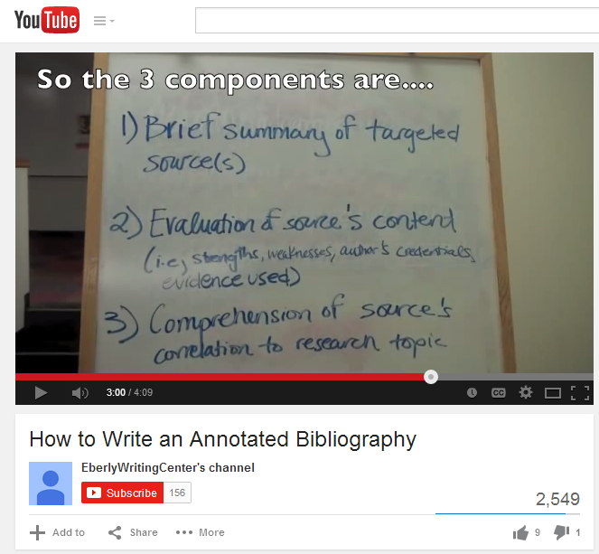

Section II- Blog Project Proposal: 500-600 word essay outlining what it is you want to write a proposal for your blog project and how your contribution will add to/ fit into the current trends in your online community.
This is the section of the paper where you get to articulate your vision for your project. What is the subject of your blog? Why did you choose it? How will you approach the topic? What kind of audience will you be writing for and how will you design your blog project to reach them? Who else is doing work like this and how are you adding to the conversation? Please use the blogs from your source analysis to think through how your project will fit into the larger field of conversation as it stands today.
This section will be much more specific and can have much more detail than your short annotations. Look again at Writing Analytically’s “Six Strategies for Analyzing Sources” (starting on page 186) to help you to be in conversation with these sources. Use your sources to ask questions about your topic and work to put sources in conversation with one another. Most importantly, however, will be your ability to articulate your own role in the conversation. Based on the sources you have seen and analyzed, what will your blog bring to the conversation? How or why will it be an important voice in the current online community?
**As with the short sources analyses, don’t forget to think about both content as well as concerns of form such as layout and functionality. **

Paper #1 Grading Rubric: Source Analysis (Annotated Bibliography) and Prospectus
5 relevant blog sites that are properly cited using MLA (or other format of your choice). 4 points per citation. | /20
Each annotation explains what the source is, what community it is in/what conversation it joins, and why it might be of use for you as you build your own blog (in other words, why you think it is interesting/revealing/or strange). 100-200 words per annotation. | /40
Prospectus is 500-600 words. This should articulate your idea for your blog and why you want to pursue this interest. Think about and describe both layout ideas and content ideas as well as how your blog fits into the conversation you see in your annotations. | /40
Grade | /100

