FOOD INSECURITY
A CASE STUDY OF BOLOGNA’S MENSE

THE BIG QUESTION:
How can we as students confront food insecurity in our own communities?

Total time to complete worksheet and associated activities: 50-55 minutes
The aim of this worksheet is to foster a conversation about “Food Insecurity.” By the end of this worksheet, you will have a working knowledge of how food insecurity affects our world and what structures exist to help people suffering from food insecurity.

PART 1: WHAT IS FOOD INSECURITY?
ACTIVITY: Before starting this worksheet, let’s see what you know! Write on the three lines below any words you associate with “Food Insecurity” or what you think it means. Think big! It is a problem that affects the entire world.
______________________________________________________________________________________________________________________________________________________________________________________________________________________________________________________________________________________________________________________________________________________________________________________________________

To be specific, Food Security, which is the opposite of Food Insecurity, is defined by the Food and Agriculture Organization (FAO) as “when all people, at all times, have physical, social and economic access to sufficient, safe and nutritious food that meets their dietary needs and food preferences for an active and healthy life.”
The opposite, Food Insecurity, is a phenomenon that stems from economic and environmental shortcomings in which people suffer and are not able to live a full healthy life because of their inability to achieve their nutritional needs. The graphic below, created by the FAO, illustrates the different levels of food insecurity.

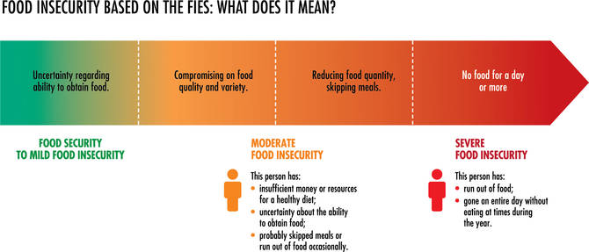
ACTIVITY: Now that you have an idea of what “Food Insecurity” means, write some ideas down that you associate with what might be causing “Food Insecurity.” To help answer the why, think about the who, what, when, and where of the problem.
______________________________________________________________________________________________________________________________________________________________________________________________________________________________________________________________________________________________________________________________________________________________________________________________________

If you wrote any words relating to poverty, lower income, climate instability/extreme climate/natural disasters, or security conflicts, you would be on the right track to answering what causes “Food Insecurity.” The FAO tracked that the places with the highest levels of “Food Insecurity” have lower overall GDP and experience many – if not all – the other “symptoms” of this problem.
However, it should be noted that “Food Insecurity” is a problem that affects our entire globe, not just developing countries. There are soup kitchens, food pantries, and food stamps programs across more developed parts of the world, such as the United States, Italy, and other European countries to serve the less fortunate.

ACTIVITY: Before moving on to the next section, watch this 17-minute video to gain a deeper understanding of the causes and reality of food insecurity: Food Insecurity is a Public Health Concern | Rayna Andrews | TEDxUWMilwaukee. What strikes you the most from this talk?
Before one can work to solve a problem, one must have the proper awareness and understanding of the issue. You have just learned a little bit about Food Insecurity. But what does Food Insecurity and hunger look like across the world? What international organizations exist to fight hunger? What is happening on a national and a local level?
PART 2: THE EFFECT OF FOOD INSECURITY ON PEOPLE AROUND THE WORLD
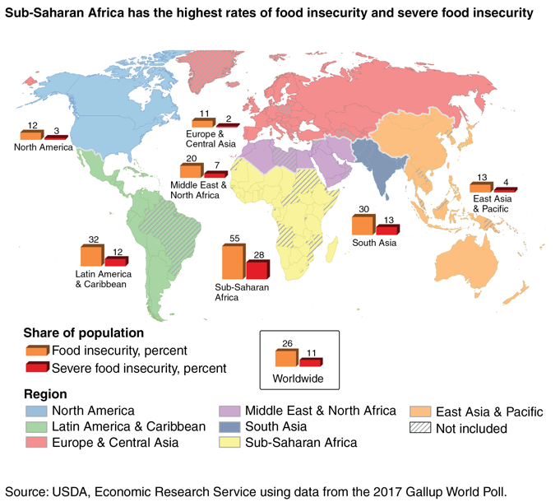Click here to see a larger version of this graphic.
There are organizations on the global scale, like the WFP (World Food Programme) and the aforementioned FAO of the United Nations, that provide support in the hardest hit areas of the world. Generally, developing countries and countries experiencing war or the post-war state are the ones that depend on the support of these two large organizations, but each country/area of reference has statistics on its respective level of food insecurity. Click the link here for the FAO statistics site.
The above graphic illustrates the degree to which Severe Food Insecurity is present, as well as that of Moderate Food Insecurity which is based on a scale standardized by the FAO which is called the FIES (Food Insecurity Experience Scale). The scale functions by asking a smattering of questions about one's ability to buy food, what kind of food they could buy, if they could not buy food, etc. Based on these questions, the percentage for each rating of insecurity is given and used to help counter the effects. The FAO defines Severe Food Insecurity as running out of food or going a day or more without food while Moderate Food Insecurity means that someone is uncertain about where their next meal will come from or when it could be.
The UN’s FAO has declared that, as of 2020, there are between 720 and 811 million hungry people (just around 10%) in the world. The chart below shows a recent uptick which has been attributed to the pandemic as well as recent conflict in areas that has halted a humanitarian ability to disperse foodstuffs.
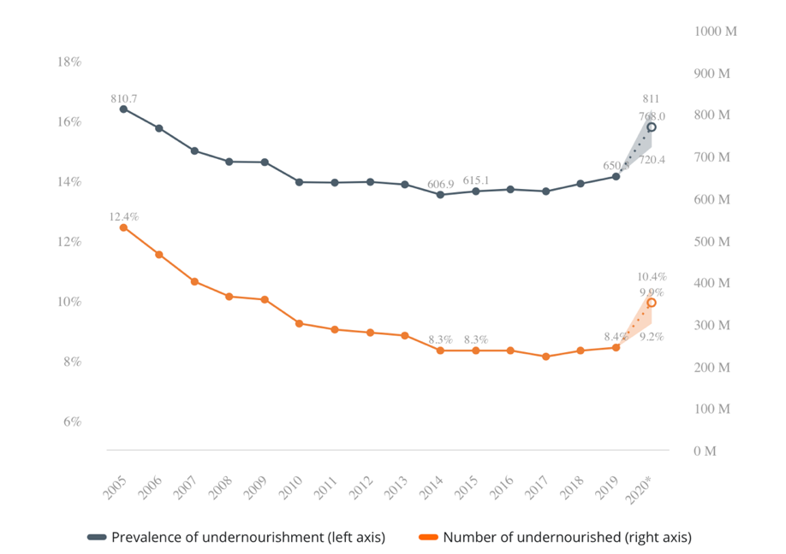FAO statistics on hunger

Italy had a three-year (2018-2020) average of 6.7 % of the population suffering from moderate to severe food insecurity. According to the USDA, in 2020, 10.5% of American households suffered from food insecurity sometime throughout the year or had very low food security.
There are different types of organizations and programs that combat hunger. In the United States, organizations like Feeding America, Meals on Wheels, No Kid Hungry, City Harvest, and Bread for the World help fight hunger. Food distribution, or how food gets to the plates of people in need, can be broken into a few categories: soup kitchens, food banks/pantries, and food stamp programs. Soup kitchens serve hot meals to guests, using food from food banks. Food banks collect and store large donations of food, which come from local businesses, food drives, and the government. Food banks then distribute these products to food pantries, which are smaller sites that give boxes of food to those who need it. The recipients of food from food pantries typically have houses, while guests at soup kitchens are less likely to have homes where they can prepare food. Finally, food stamp programs serve low-income families by giving them certificates, or “food stamps” that can be used to purchase certain types of food at the grocery store.
So, how can you help combat hunger in your local community? Donate your time and money and educate yourself about how hunger affects your area. Volunteering at soup kitchens, food banks, and food pantries, donating money to organizations that provide relief for food insecurity, and participating in food drives are just some of the ways to help. Complete the following activity to learn more about what you can do in your local community.
ACTIVITY: Read this article on 9 Ways to Help People Facing Hunger in Your Community, and do an internet search to see what local organizations are fighting hunger near you. Search the name of your town, plus keywords like “hunger relief,” “soup kitchens,” “food banks,” and “hunger.”
PART 3: CASE STUDY OF TWO MENSE IN ITALY
To gain a better understanding of food insecurity and relief organizations in Bologna, we volunteered at two different organizations, Antoniano and Cucine Popolari. Although these two mense (“soup kitchens” in Italian) are structured differently, with one being a religious organization and the other a civic, both are based on the common goal of serving those in need.
ANTONIANO:  Antoniano is a Franciscan organization that was created in the 1950s to foster the development of youth, particularly those who are less fortunate. In addition to the mensa, which serves roughly 120 adults, Antoniano also has art and culture classes for kids and is famous for the annual children’s song competition, Zecchino d’Oro. One of the main goals listed on the organization's website is “solidarity;” the aim of this Franciscan center is to support those who are homeless, hungry, unemployed, or refugees and treat them with respect and kindness to create solidarity between people. | CUCINE POPOLARI:  Cucine Popolari is a project of CiviBo, a civic organization founded in 2014 by Roberto Morgantini, who used donations from friends, family, and the community to create the first mensa. There are now four locations of Cucine Popolari throughout Bologna. Unlike Antoniano, Cucine Popolari is neither connected to the commune of Bologna nor a religious group. In addition to serving meals to the hungry, Cucine Popolari is also involved with the community in other ways. In a monthly newsletter, it promotes cultural activities and voices support for other social justice causes.

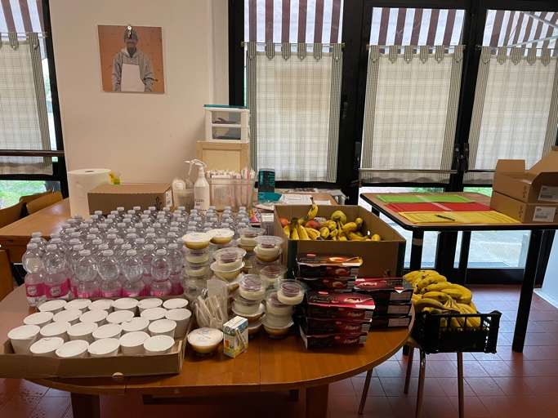
Both organizations receive food from a variety of sources – in the form of donations from local grocery stores, subsidized food from the European Union, and extra food purchased using funds of the mense. The format of each meal is the same at both mense as well: the first course, which is usually pasta or a hearty soup; the second course, which is usually a protein (meat, eggs, or cheese) with vegetables; bread, fruit, and water. Both mense must carefully prepare and serve food that fits each person’s dietary needs. Many guests at the mense do not consume pork for religious reasons; there are also guests who prefer vegetarian meals, cannot eat gluten, or are allergic to certain foods.
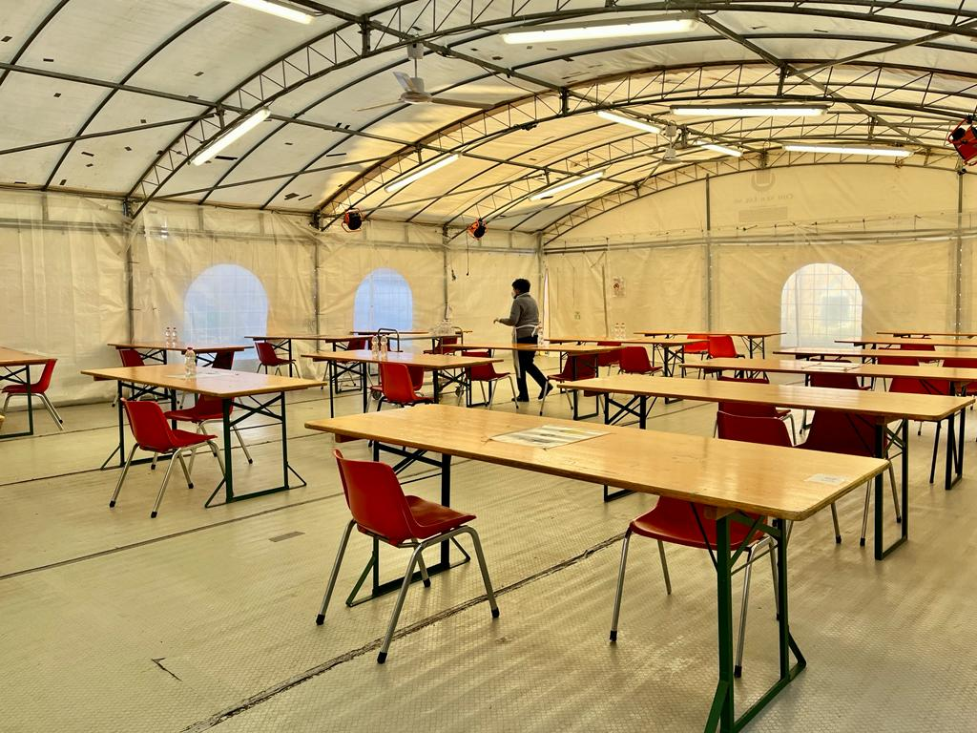
To qualify for a meal at a soup kitchen, people must go to the social service office, which confirms that they have a need for food. Then each day they come to the soup kitchen, they present their cards at a check-in table. At Antoniano, there are 150 guests registered for meals, although not everyone shows up for a meal every day. Cucine Popolari has significantly more guests since there are four locations. At the location we volunteered at, 80-100 meals were prepared each day, although there were 110-120 people registered for meals. The COVID-19 pandemic affected service in soup kitchens around the world, including at Antoniano and Cucine Popolari. While Antoniano has resumed in-service with social distancing and new disinfecting procedures, Cucine Popolari continues to serve packed meals. Because of this difference in service, we had different roles at each place. At Antoniano (pictured above), we served guests at the table, fetched extra items for guests (such as extra water, food, salt and pepper, etc.), and cleaned and reset tables for new guests. At Cucine Popolari, we packed plastic bags with bread, fruit, and hot food and assisted with the distribution of the meals.

ACTIVITY: To understand better the typical experience of those who volunteer at a soup kitchen and those who are served, watch this 7-minute video, A Day in the Life of a Soup Kitchen. Read the quotes below from volunteers at Cucine Popolari and Antoniano.

I don’t want to be good; I want to be just. So, in my opinion, it is right that all must eat, have a home, have access to healthcare, and access to education. I am happy to work to distribute food... the difference in my method is that I am straightforward with them, if they want to eat, they can eat...because I don’t care to be good, I care to be just. -Rudi Conti, Cucine Popolari
I believe very much in the fact that citizens can and should (without being forced) take on the “problems” of the society in which they live and that this is to their own benefit.
-Alessandro Patroncini, Antoniano
I started this experience because I had a free Friday, and once I started, I realized that using my free time in a way that benefits others brought me satisfaction. -James Marks, volunteer
Through our extended volunteering project at Antoniano and Cucine Popolari, James and I were able to form meaningful relationships with our fellow volunteers, get to know some of guests, and gain a better understanding of food insecurity in Bologna. -Mary Ritter, volunteer

DID YOU ACHIEVE THE EXPECTED OUTCOMES?
After reading the information and completing the activities in this handout, we hope you have learned...
- More about the scale of food insecurity and how it affects communities on a global and local level
- How soup kitchens help relieve hunger in communities
- How hunger is likely affecting your area and what local organizations are fighting it

TO SUM UP: OUR TAKEAWAYS
This was one of the most worthwhile experiences I could have had while abroad. Not only did it allow me to use my Italian language skills in a real-world context, but I was also able to become involved in the Bologna community and learn more about how hunger affects people in Bologna, particularly immigrants. As a privileged student from the United States, I thought it was important to serve my new community, for a new cultural perspective but also to give back.
After volunteering at Cucine Popolari for both semesters, I felt a particular connection with the volunteers and guests there, and I know that I will miss going there every Friday. At both mense, I began to recognize guests each week and see them around the city. This was an eye-opening experience, especially to learn about some of their individual situations, and my compassion for people in need deepened. -Mary
Seeing the guests every week and building a rapport with them over time is a memory that will forever live in my mind as it was truly humbling to meet people who crossed seas and oceans to try and build a better life, and others who were from Bologna but in challenging times and seeing some of them in the streets without much hope is a rough thing to see. But it was an experience that I will cherish and has inspired me to find more time in the future to do something similar. It made me realize that all acts of service are worthwhile. -James
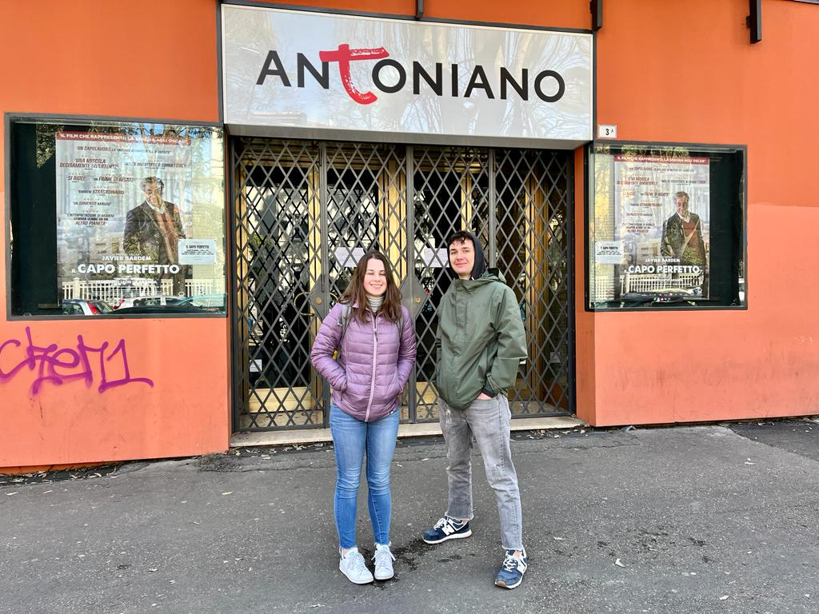
BIBLIOGRAPHY:
Websites:
Food security definition - https://aifsc.aciar.gov.au/food-security-and-why-it-matters.html
Antoniano Bologna - https://www.antonianobologna.it/
CiviBO/Cucine Popolari - http://www.civibo.it/
Articles:

Who Are the World’s Food Insecure? Identifying the Risk Factors of Food Insecurity Around the World? - https://www.ers.usda.gov/amber-waves/2019/june/who-are-the-world-s-food-insecure-identifying-the-risk-factors-of-food-insecurity-around-the-world/
The State of Food Security and Nutrition in the World, 2018 -https://www.fao.org/3/I9553EN/i9553en.pdf
The UN Sustainable Development Goal for Hunger with stats on how many suffer from hunger -
https://www.un.org/sustainabledevelopment/hunger/
12 Organizations Helping to Win the Fight Against Hunger in America -https://thatscaring.com/blogs/the-cause/14770297-12-organizations-helping-to-win-the-fight-against-hunger-in-america
Food Banks vs. Food Pantries - https://regionalfoodbank.net/frequently-asked-questions/#:~:text=A%20food%20pantry%20provides%20food,day%20for%20many%20of%20them.
Food Banks vs. Food Pantries https://nwpafoodbank.org/get-educated/food-bank-vs-food-pantry/

Images and videos:
Infographics - https://www.fao.org/hunger/en/

