THE RESEARCH PROJECT

THE BIG QUESTION:
What is a research project? Is it an extended version of an academic paper? How’s it different from a research plan or a research proposal? Is there one, fixed, way to build a research project?

TIME FOR THIS WORKSHEET: about 2 hours x 3 days (Week 2)

WHY DOES IT MATTER?
Research is an invaluable approach to academic learning that allows individuals (students and faculty alike) to pursue their interests, gain new knowledge, improve problem-solving skills and challenge themselves in new ways. In particular, for students the process of conducting research also is particularly valuable as it allows them to reflect on their own skills, see themselves in action (from the initial conception of a an overarching question to the successful execution of a project and the subsequent realization of a final outcome), make choices (what is/isn’t relevant, what to include or not include…), interact with others (ask clear questions and process answers).

DEEP DIVE, PART 1: DEFINITIONS
Research is a process of careful inquiry. This means collecting data and important information, that are analysed and interpreted in accordance with the rules of specific professional fields and academic subjects. Research is conducted with the aim of evaluating the validity of a hypothesis or an interpretive framework. It aims to assemble a body of substantive knowledge and findings for sharing in appropriate ways. Research can also generate questions for further inquiries.

A research project for students is an extended essay that presents a question or statement for analysis and evaluation. During a research project, you will not only analyze existing knowledge on a specific subject but present your own ideas and findings thus producing new knowledge.

 | READ & REFLECT:  Our knowledge, thoughts, perceptions and actions are influenced by our worldview, which is a collection of attitudes, values, tales, and expectations about the world. One’s view of the world is at the heart of one’s knowledge. Have you ever considered that you can contribute to this worldview by creating new knowledge?
In these initial stages of the project, the difficulty may be to narrow down the scope of your topic so that you can explore it in depth… but not too narrow or there won’t be enough to research on. To avoid this, think about creating sub-topics/questions. Think about “The Five W’s”:
click on image to open a larger version 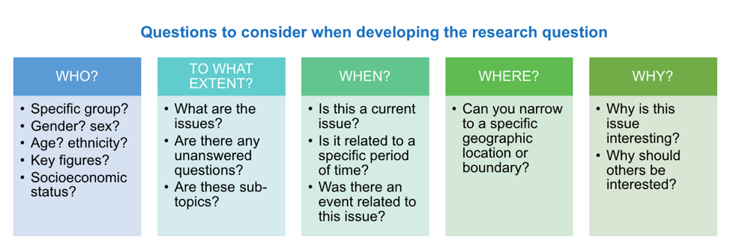
“The best research project ideas develop from areas you already have an interest in and where you have existing knowledge.” While you identify an overarching question (and related sub-topics/questions), one that motivates and inspires you to start researching, also keep in mind what the outcome of the process will be, that is a research paper, so that you can plan appropriately. According to the University of Sheffield there are 7 SECTIONS in a research paper: introduction, literature review, methodology, findings and results, discussion, conclusion, and references (don’t forget to include a list of correctly cited references to avoid issues with plagiarism).

DEEP DIVE, PART 2: RESEARCH STRATEGIES AND THE LITERATURE REVIEW
Most research is produced in the form of a written account, such as an article, a report, a dissertation or a conference paper. It is important to share these findings because research aims to contribute to our collective understanding of the world. Sharing research findings is important and today’s wide availability of findings is a real game-changer, as it allows researchers to piece together rather quickly various “stories” (the reports and accounts detailing the research findings). Research, particularly qualitative research, can be likened to a detective story. The goal is to understand people’s thoughts, feelings, and actions. Researchers don’t just count numbers. They also collect stories and descriptions. This helps them to learn more about a topic.

However, if, on the one hand, findings are more readily available, the quick way the internet has facilitated the research process has, simultaneously, made it more complicated. The level of ease with which we can access materials and ideas, presented in a variety of formats including articles (academic or not), videos, blogs, and social media, poses a significant challenge to researchers, as they are required to consider a vast array of data. Research today requires not only a clear vision, but also strategic thinking. Research in a university setting requires you to think critically about information, and to use new types of information sources and tools to find, access, understand, and use the right information. The U. of Galway has identified 5 RESEARCH STRATEGIES to ensure research stays focused and relevant and is completed to a high standard.

 | READ & ANSWERS:  Click on the link above from the U. of Galway and read about the 5 strategies. Pause and reflect: what strategies define your approach to research? Which are easier for you, and which are not? What worries you about the idea of conducting research?

This initial phase of a research project often produces a piece of writing called “Literature Review”, that is a scholarly assessment or a critical evaluation of the existing material on a particular subject, which distinguishes it from a literature report.
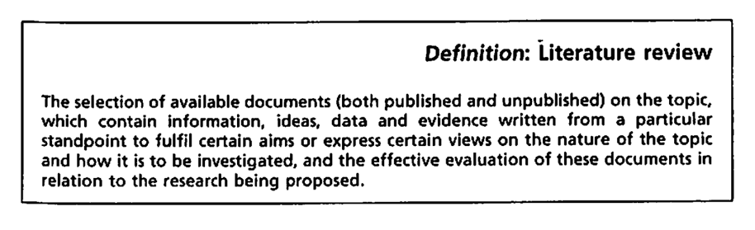
Hart, Chris. (1998). Doing a Literature Review (p. 13)

To understand the difference between reviewing and reporting, think about articles that talk about TV or films. These articles include a summary of the film or program, and the critic’s own thoughts about it. Similarly, a literature review has two main goals. First, it looks at what research, theories and evidence already exists. Second, it allows you to share your own thoughts on this content. Here’s a useful list of: 1. what makes a literature review (= what parts must be included) and 2. how to organize it (different types exist based on what you intend to do):
- What are the parts of a lit review? Introduction - Body - Conclusion
- How should I organize it? Chronological - Thematic - Methodological - Theoretical

READ & DECIDE:
Browse through the links above: read about the different ways to organize a literature review and begin thinking (maybe even decide) how you’d like to structure yours and why.

A good way to learn how to write literature reviews is to find and study some good examples. Here’s a short collection of annotated sample literature reviews written by scholars at UW-Madison. Review these samples as they show how you can make your idea fit with other research:
- SAMPLE 1: a 1-page literature review by a political scientist
- SAMPLE 2: a 4-page lit. review in a published, academic article about philosophy
- SAMPLE 3: a brief lit. review in a published, academic article about photochemistry

 | READ & COMPARE:  What differences do you notice in these 3 sample literature reviews?  How does the writing style changes based on the topic or discipline?  What style attracts you the most and why?

DEEP DIVE, PART 3: CASE STUDIES
The are several ways of doing social science research (survey research, experimental research, case research, interpretative research – see pp. 73-111 HERE for a detailed description of each approach). Case studies are usually the best option when the researcher seeks to understand HOW or WHY something happens, when the investigator can’t control what happens, and when they’re looking at something that’s happening in the real world. This is why, through shadowing and first-hand observation in Bologna, you will be more likely to engage in research that is of the third and fourth type.

As Yin explains in the book “Case study research: Design and methods”, the case study is a well-established research strategy that is employed in many situations to enhance our understanding of a wide range of phenomena, including individual, group, organizational, social, political and related aspects. As would be expected, the case study has been a common research strategy in psychology, sociology, political science, social work, but also business and community planning. Case studies are also used in economics, for example to investigate the structure of a given industry or the economy of a city or a region (Yin 2013, p. 1). Case studies are important and needed because they help us to understand complex social phenomena. The case study method is a valuable tool for investigators, as it allows them to retain the holistic and meaningful characteristics of real-life events.

Through your shadowing placement in Bologna, you will have the vantage point of observing a “case study” in action from within. That is why,

READ, COMPLETE & WRITE:
Open the link to “Case study research: Design and methods” and carefully read the section titled COMPARING CASE STUDIES WITH OTHER RESEARCH STRATEGIES IN THE SOCIAL SCIENCES (pp. 3-9). Try and apply information found here to the shadowing placement you have agreed to be part of during this program. Can you begin to shape your research questions?

END OF THIS WORKSHEET: HAVE YOU ACHIEVED THE OBJECTIVES?
- Provide a definition of what a research project is
- Understand broadly what research is and does
- Define what a literature review is and decide how you’d like to organize yours
- Begin shaping your research question

TO SUM UP:
In this worksheet, you have explored the question of what is (and makes) a research project. Through various definitions, you have expanded your idea of what research for university students looks like, what it does and who is it for. One of the main points this worksheet has attempted to make is that the question you will try to answer by means of the research project will have to arise from a genuine interest of yours, a curiosity you have, and observation you’ve made. From here, you’ll begin shaping your research question and, consequently, your project and its outcome, the research paper. Finally, in this worksheet you have found practical information on different research strategies as well as the various components that, all together, make up a research paper.

Bibliography
Academic Resources:
- How to do a research project for your academic study (U. of Sheffield)
- Learn how to write a review of literature (U. of Wisconsin–Madison)
- Literature review (U. of Edinburgh)
- Research Strategies (U. of Galway)
- Undergraduate Research and Creative Scholarship (U. of Montana)
- Ways of Creating Knowledge (James Cook U.)
- What is research? (Hampshire College)
- Writing a Literature Review (Purdue U.)

Academic Articles/Chapters:
- Hart, Chris. (1998). Doing a Literature Review: Releasing the Social Science Imagination. Thousand Oaks: Sage Publications. Excerpts
- Yin, R. K. (2013). Case study research: Design and methods. Sage publications. Excerpts.
Web-articles:
- Is the Research Trustworthy? Learn to Think Like an Investigator
- Module 1: Introduction: What is Research?
- Chapter 6 Developing a research question

Social Media:
- Studywithpsychodidi (Instagram)

