How is Sustainability Defined?
Sustainability at Dickinson explores a fundamental question: How do we improve the human condition equitably in this and future generations while conserving environmental systems necessary to support healthy and vibrant societies? Answers are complicated by continuing racism, deepening inequality, globalizing social and economic institutions, changing technologies and a growing human footprint that is rapidly changing the Earth’s atmosphere, climate, oceans and ecological systems. These dynamic forces interact in complex ways with continuing challenges of human and economic development, food and energy security, health, injustice, poverty, access to clean air and clean water, environmental degradation and species extinction. A healthy environment is necessary but not sufficient for sustainability. A sustainable society is also, necessarily, just, equitable, inclusive, without violence, and without racism.
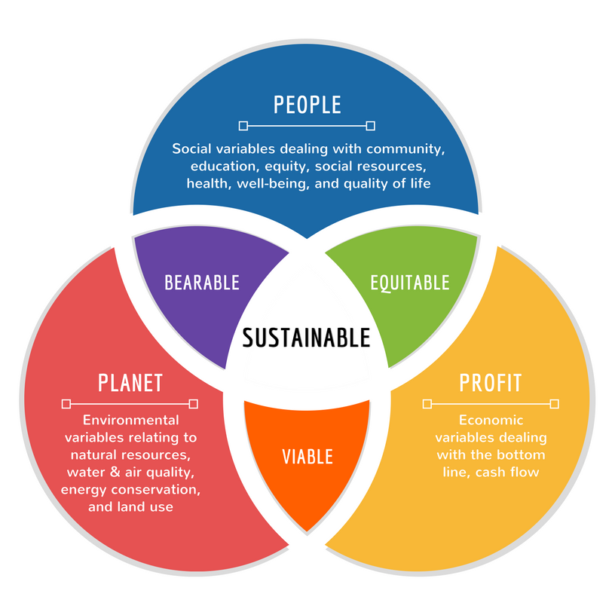
Via Maricopa College Sustainability

Many people and organizations have adopted a model of overlapping the lens of people, planet, and profit to help define sustainability. Finding solutions that are bearable, equitable and viable – the trifecta win – are what we hope to achieve as we examine complex interdependencies.
View and Engage:
What is sustainability? Defining it is difficult, but this video provides a nice introduction to its core concepts and time scales. Please watch- it is only 1 minute 43 seconds.
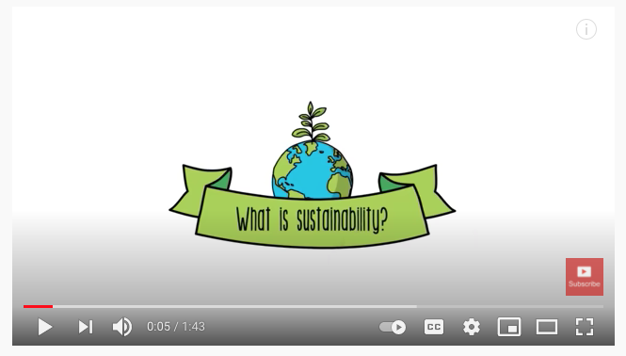
Question for Reflection: How might culture play into how sustainability is defined or demonstrated in communities?
Review & Engage: How do you define sustainability?
Check out the image deck here – “What is Sustainability Images”. Select one image that most closely represents what sustainability means to you and think about how you define sustainability. Think about why you chose the image you did. Make some notes. Be prepared to share during breakout conversations at the workshop.

